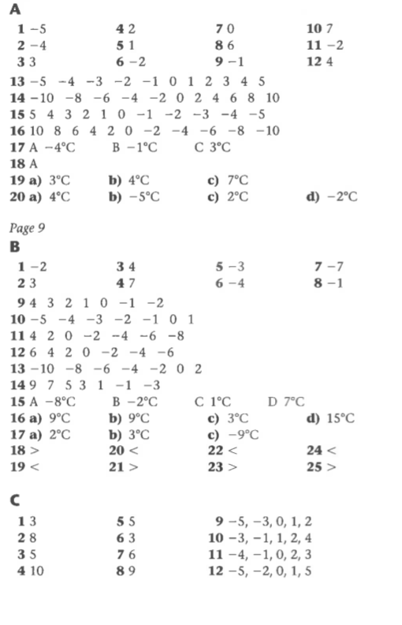
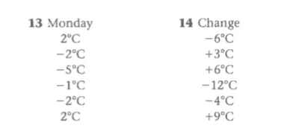

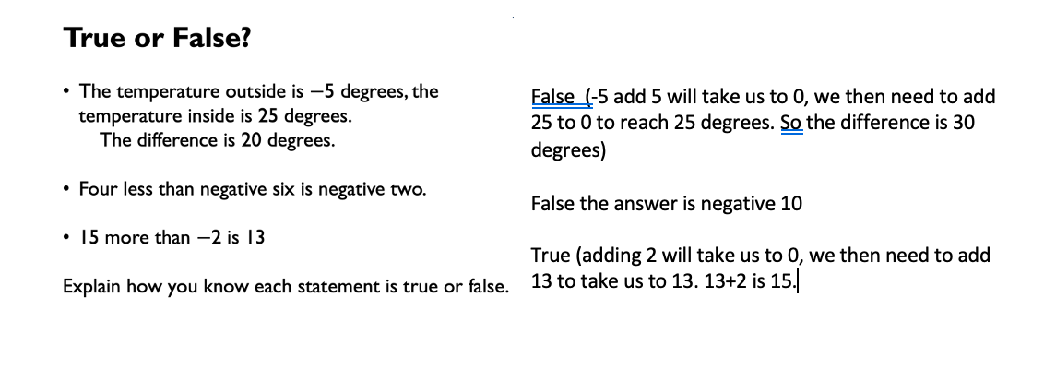
The correct order is:

The even number between -18 and -22 -20
The number that is half way between 40 and -50 -5
The difference between -6 and 7 13
The difference between -24 and -76 52

