12.01.21
Maths

In maths today we will revise our multiplication. We are all great with our tables but how do we find the answer to 34x5 without having to count.

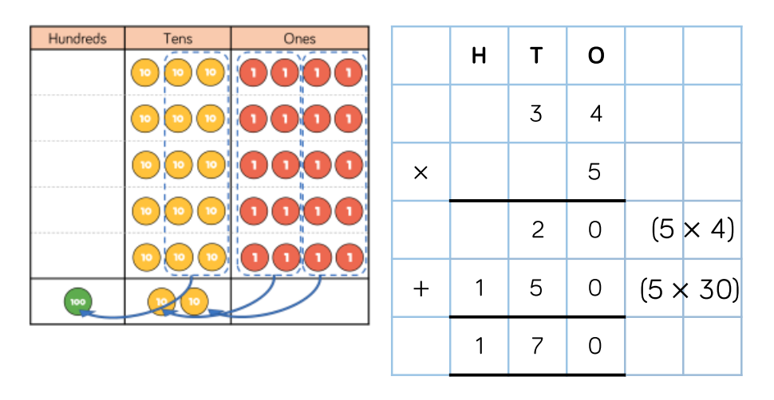
Now there are 2 ways to approach this. In the example below the larger number has been partitioned in to tens and ones. The ones are multiplied first, then the tens and the answer is the total of both sums.

If you are confident with the above then you can use the quicker method where you have to remember to carry numbers from the next column to add to the next multiplication.

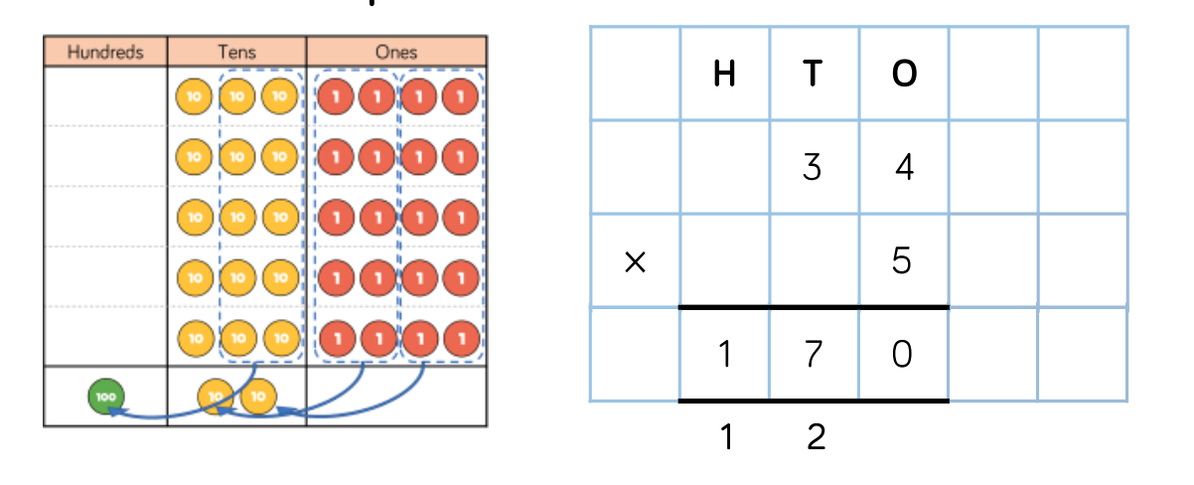

Please complete either A, B, or C below and try to answer at least one challenge question.

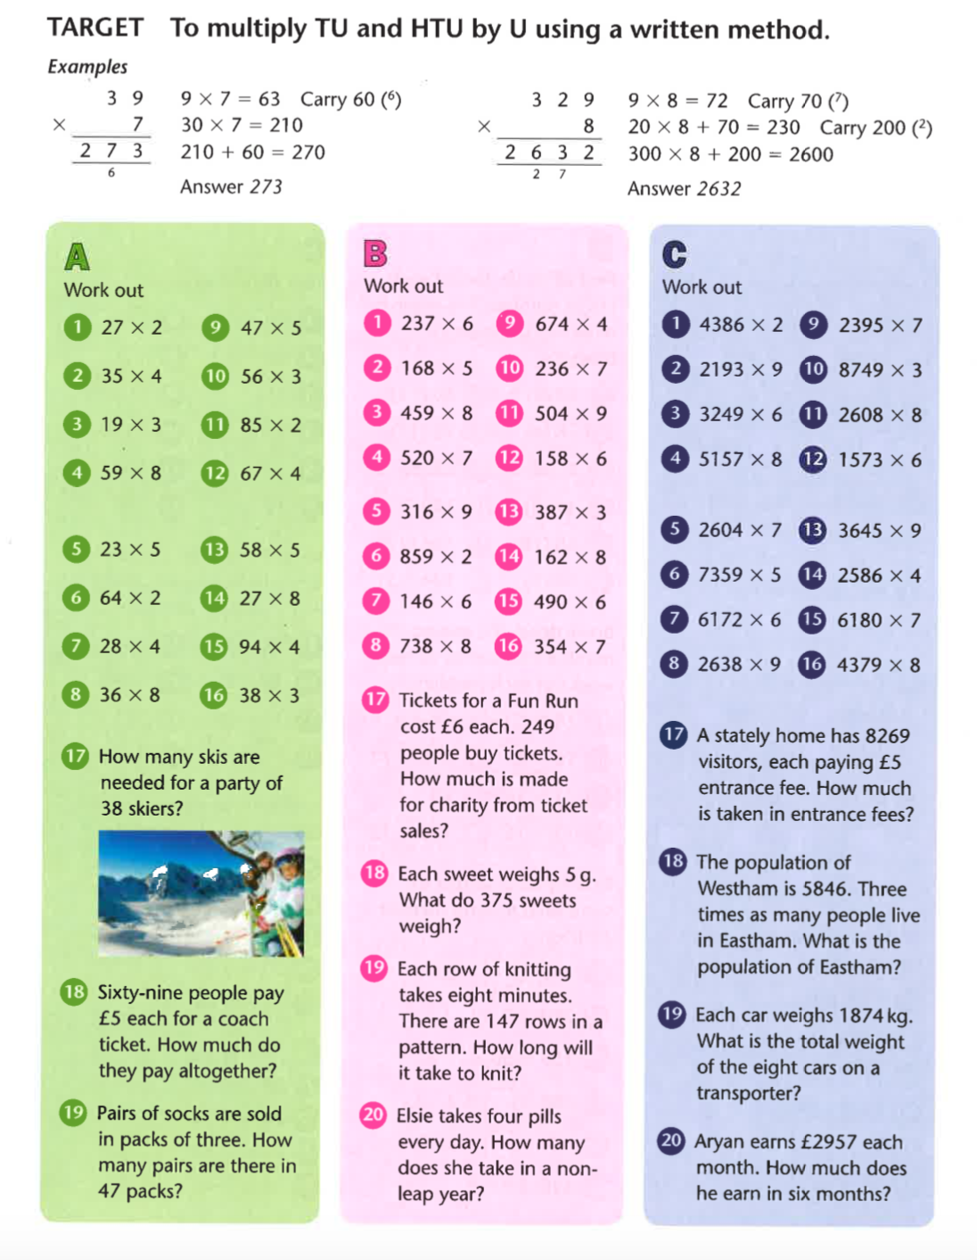

Challenge

