Maths – 05.01.21

We shall continue revising maths we covered in our previous two terms.

Negative numbers Positive numbers
Below 0 Above 0
Have a minus sign

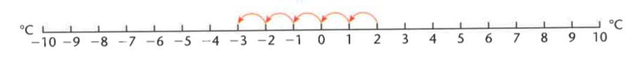
If the temperature is 2 degrees and it falls by 5 degrees the temperature is -3 degrees.

Choose from A, B or C then have a go at a challenge question. Good luck!

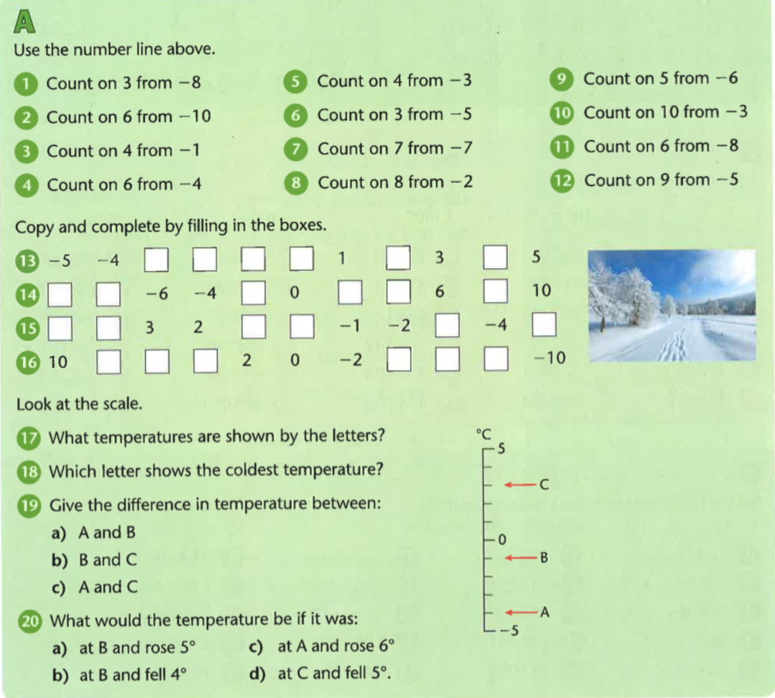

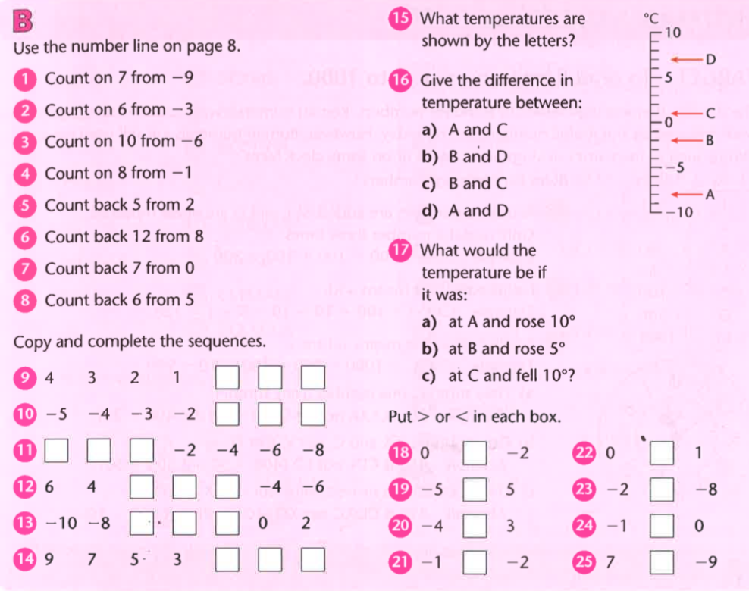

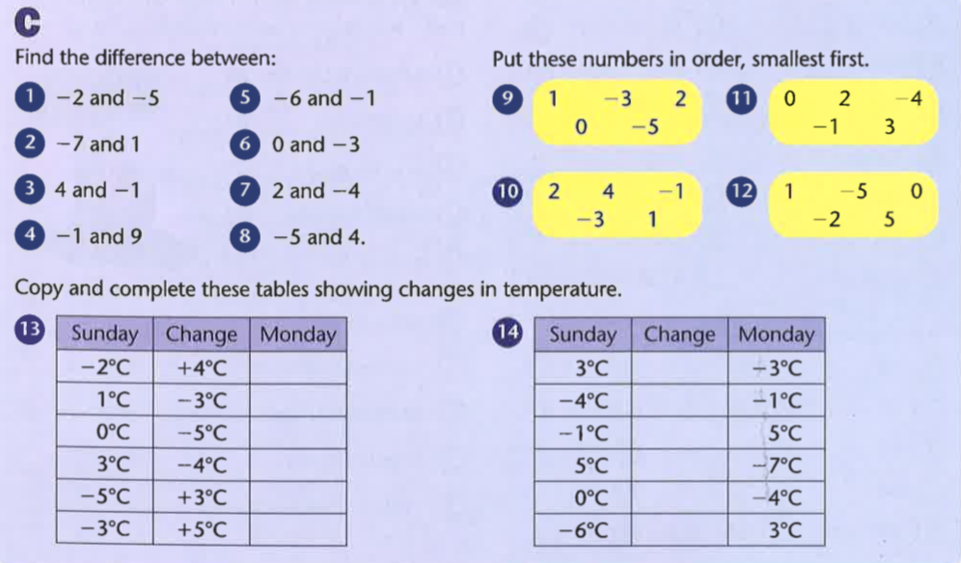

Challenges
