Friday 22 January 2021
LQ: Can I recall the main events of Moses’s life and understand how the themes of justice and freedom are important?
Write what happens to Moses during this part of his life. Use the pictures as prompts. If you didn’t come along to the Teams lesson then you can read the bible text that’s attached and/or watch the video https://www.youtube.com/watch?v=RdSQT7DS1lI up to the Ten Plagues. We will look at those next week.
Picture and Key words | Events
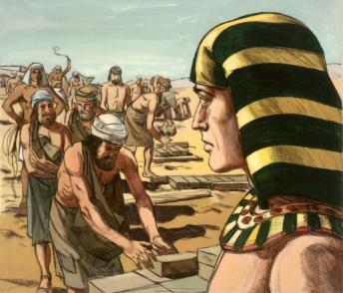  Israel, Hebrew, Egypt, Pharoah, slaves | _________________________________________________________  _________________________________________________________  _________________________________________________________  _________________________________________________________  _________________________________________________________  _________________________________________________________  __________________________________________________________  __________________________________________________________  __________________________________________________________  __________________________________________________________  __________________________________________________________
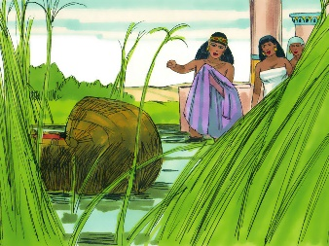  Moses, basket, reeds, Nile, Princess, daughter, Pharoah | __________________________________________________________  __________________________________________________________  __________________________________________________________  __________________________________________________________  __________________________________________________________  __________________________________________________________  __________________________________________________________  __________________________________________________________  __________________________________________________________  __________________________________________________________  __________________________________________________________  __________________________________________________________
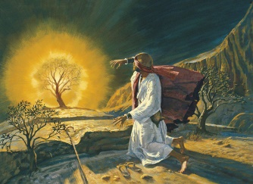  Midian, unjust, Mount Sinai, flame, burning bush | __________________________________________________________  __________________________________________________________  __________________________________________________________  __________________________________________________________  __________________________________________________________  __________________________________________________________  __________________________________________________________  __________________________________________________________  __________________________________________________________  __________________________________________________________  __________________________________________________________  __________________________________________________________
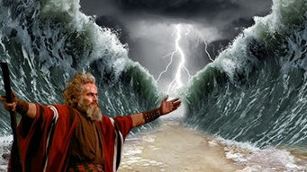  Pharoah, freedom, Promised Land, refused, escaped | __________________________________________________________  __________________________________________________________  __________________________________________________________  __________________________________________________________  __________________________________________________________  __________________________________________________________  __________________________________________________________  __________________________________________________________  __________________________________________________________  __________________________________________________________  __________________________________________________________

Learning Question
How do you think the theme of justice runs through the story of Moses?
________________________________________________________________________________________________________________________________________________________________________________________________________________________________________________________________________________________________________________________________________________________________________________________________________________________________________________________________________________________________________________________________________________________________________________________________________________________________________________________________________________

