29th January 2021 – PE

Although this session streamed live last Wednesday you can still access it on chancetoshine.org/live.

This session will support children to improve their ball striking skills. The activities can be completed indoors. Children will need to find some items to use to take part. You will need:

Something to hit with: try a bat, a frying pan or a hard-back book
A ball or rolled up pair of socks
A wall to rebound the ball off with about 2m space around you to complete the activity safely
4 items to use as targets; plastic cups, empty tubs would be perfect
This week also offers the opportunity for some pairs work if you have a willing companion. However, the activities can be completed solo.

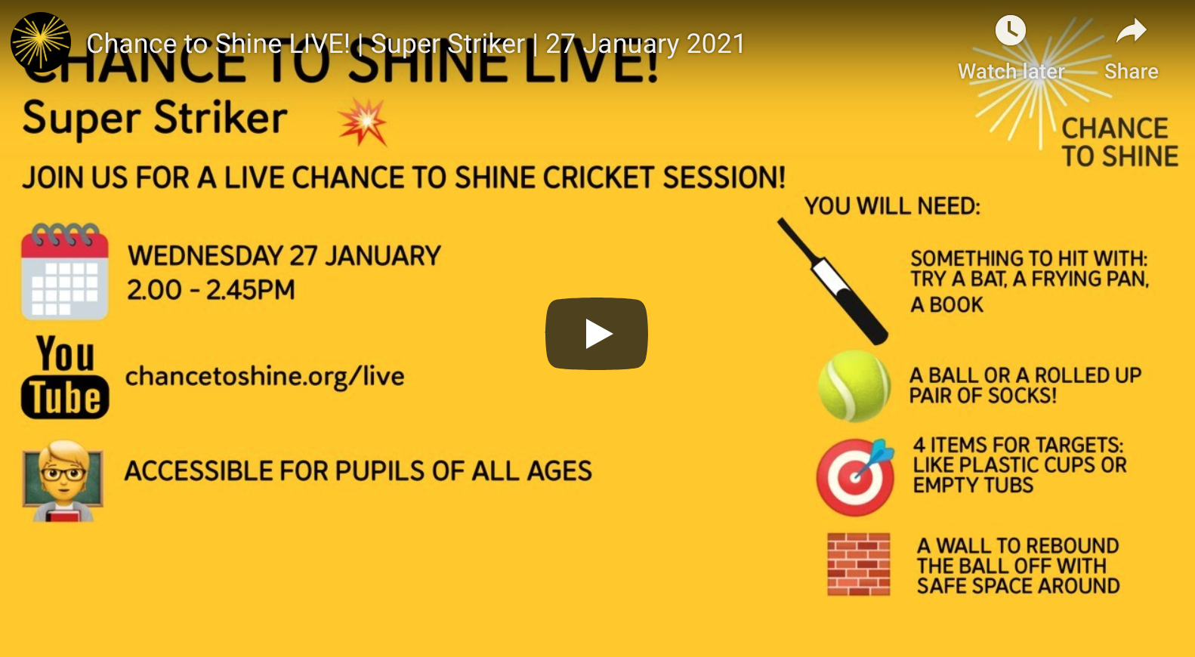

Let me know how you get on!

