29.01.21 – Maths
Today for your warm up I’d like you to spend 5 to 10 minutes practising your tables at https://www.topmarks.co.uk/maths-games/hit-the-button. See how you get on!

We are continuing our work on equivalent fractions today. Please complete the following. Remember if it asks you which is the odd one out it means which one is not an equivalent fraction.

If you are confident choose 5 questions from one of the sections below then complete the challenge questions.

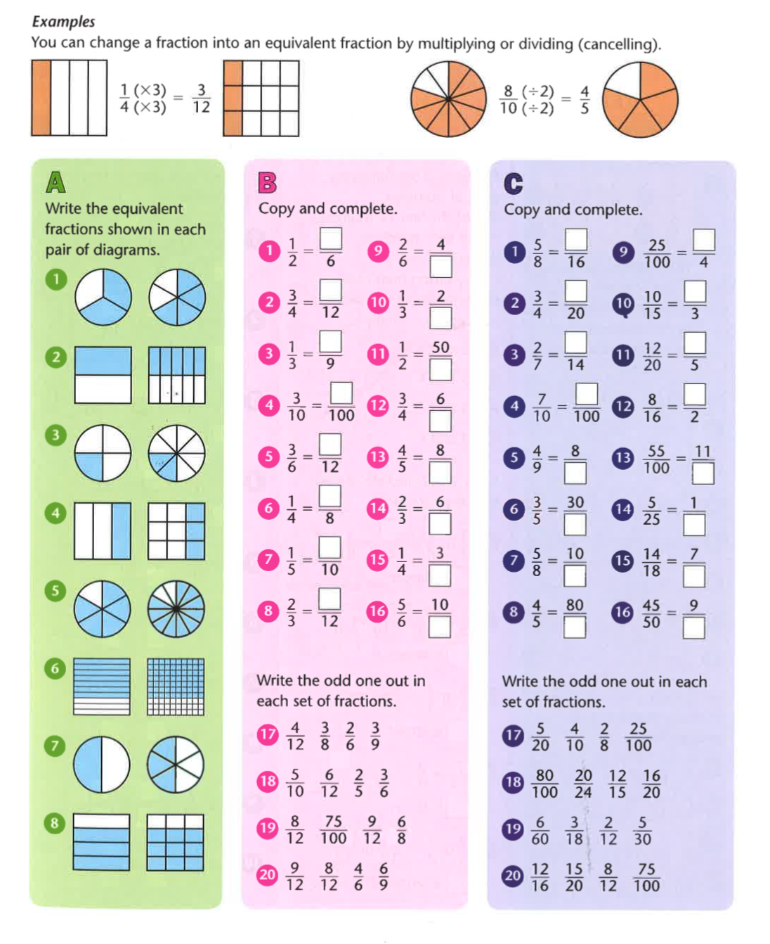
CHALLENGES
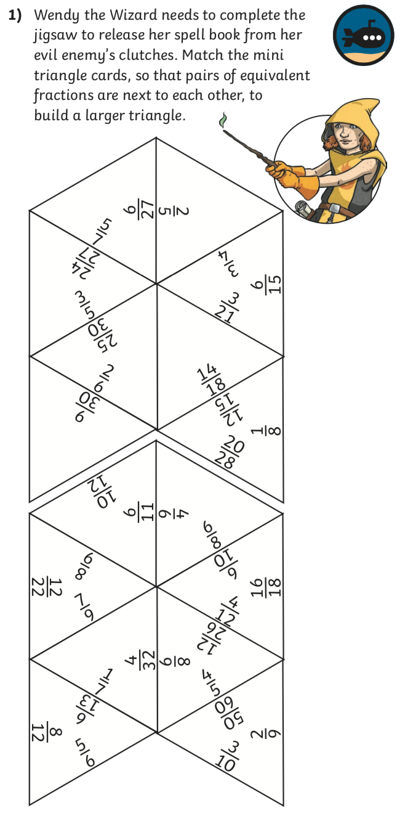
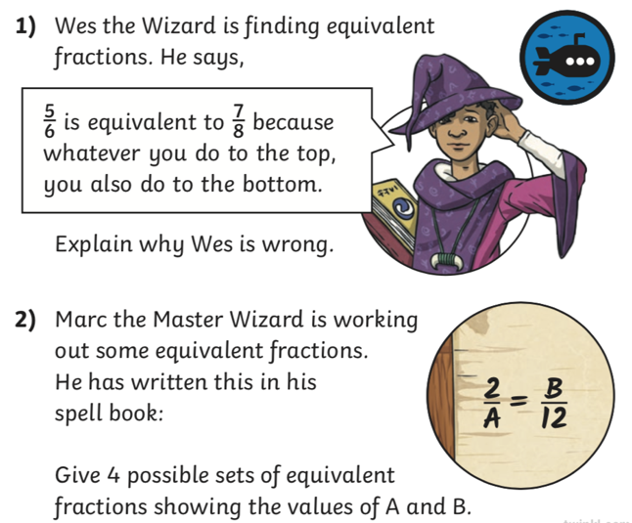

ANSWERS

