Thursday 28th January 2021

LQ: Can I name parts of the human digestive system and know what they do?

Have a go at drawing where you think the body parts are that make up the human digestive system. Don’t peep ahead, just have a go at thinking about the journey your food takes everyday.

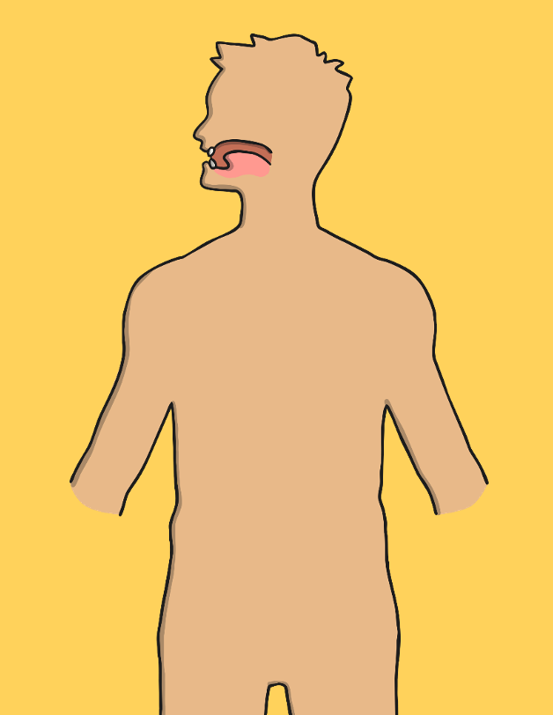

Tick any of the body parts you labelled correctly.

Were there any body parts you missed out? If so what were they?

_________________________________________________________________________________________________________________________________________________________________________________________________________________________________

Did the position or name of any of the body parts surprise you?

_________________________________________________________________________________________________________________________________________________________________________________________________________________________________

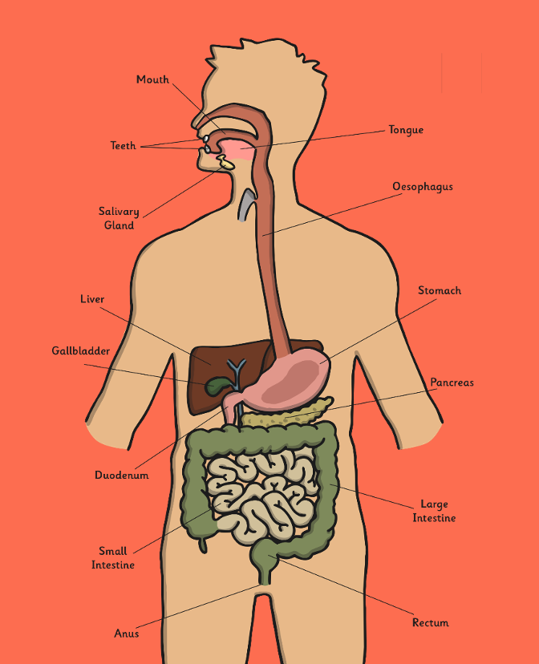

Now have a go at filling in the diagram below and/or complete the cut and stick activity. Be careful with the spellings. These body parts are very tricky to spell!

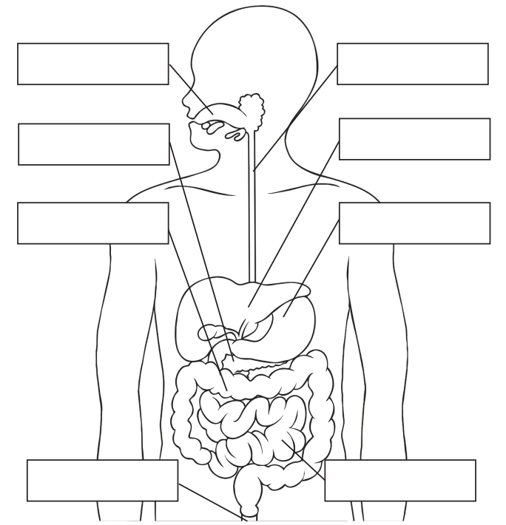

This is the cutting and sticking activity. The answers are on the final sheet if you want to check before you stick!

