27.01.21
An Introduction to Fractions.

Please have a read through the powerpoint then answer the following questions.
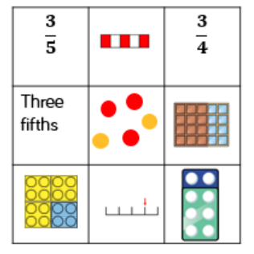
1) Here are 9 cards. How could you sort them out?

Can you find any different ways to organise them?

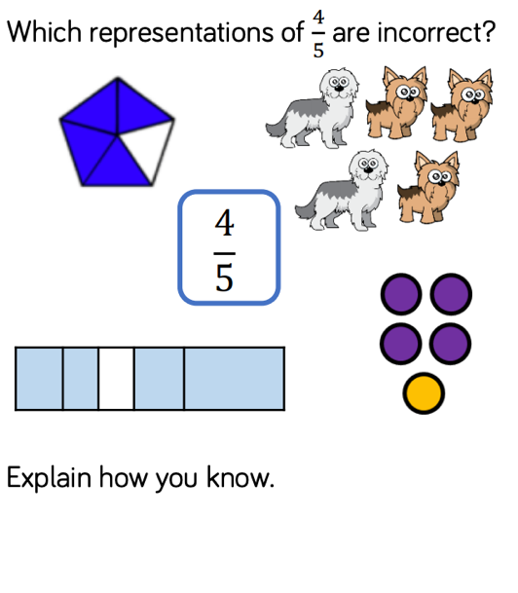
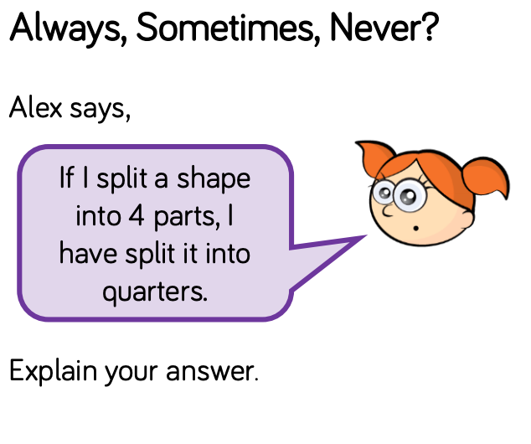

4) What is half of 8? What calculation do you do to find one half?

CHALLENGE

I am aware that some of you may well be familiar with fractions. So to keep you occupied after you’ve refreshed your fraction knowledge I’ve got a bit of a Dicey Problem for you to solve!

