Wednesday’s Answers

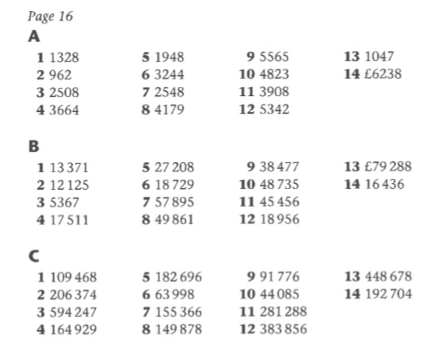

Rosie forgot to take a hundred from the hundreds column when she stole it to move to the tens column. The correct answer is 21,080.

55907
28,485 27,422
15,094 13,391 14,031
8,118 6,976 6,415 7,616
4,946 3,172 3,804 2,611 5,005

Tommy’s method is incorrect. The milkman had 250 then collected another 160 bottles. So the first step is to work out how many bottles the milkman had all together. 250+160=410 bottles. Then he delivered 375 so we need to subtract 375 from 410. The correct answer is the milkman has 35 bottles left.

