13.01.21
Maths

We will have 1 more day of multiplying by 1 number. It is important we feel confident with this before moving on to multiplying by 2 numbers. Today the tables are harder but the technique is exactly the same.
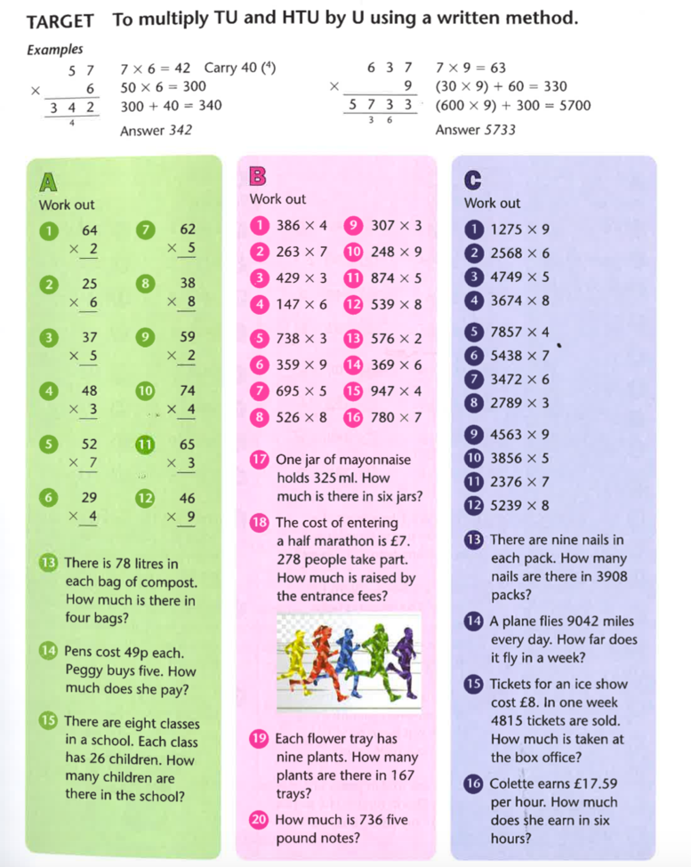

Challenge Questions

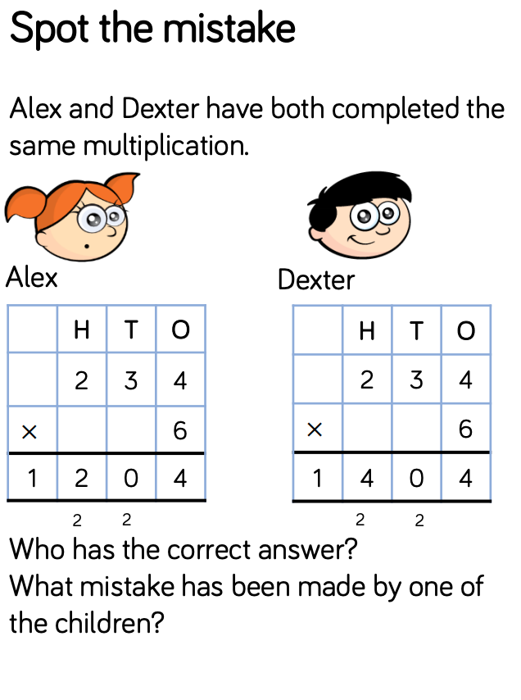
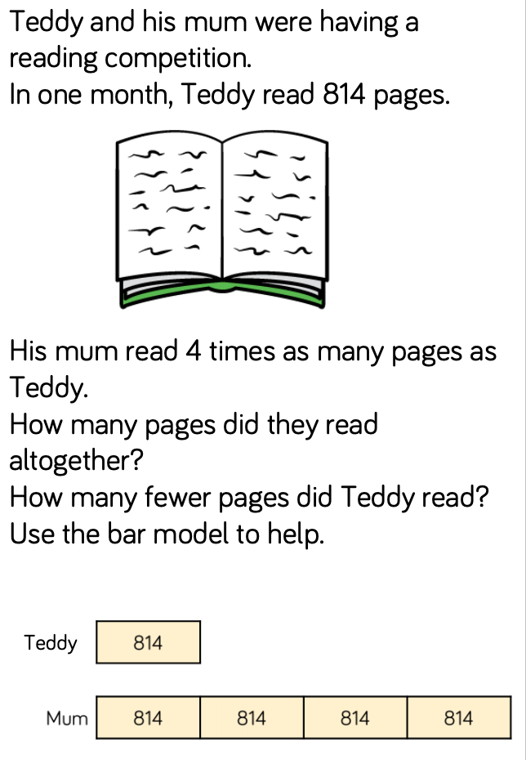

Answers

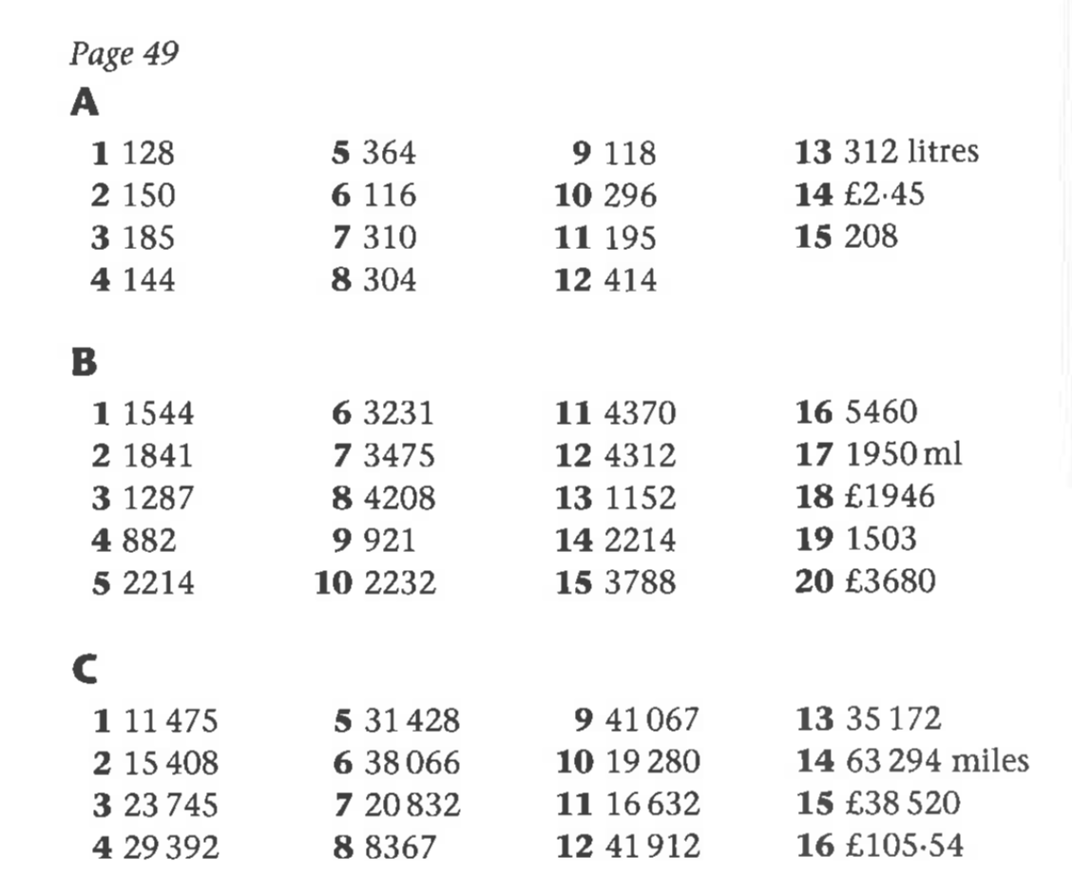

Challenge Answers

Dexter is correct. Alex forgot to add the two hundreds she exchanged from the tends column.

814 x 5 = 4,070
They ready 4,070 pages altogether
814 x 3 = 2,442
Teddy read 2,442 pages fewer than his mum

