Wednesday 20th January 2021
Maths
Dividing a 2 digit number by 1 digit.

Remember to divide means to share equally.
Below I’ve made 39 from 10s and 1s counters. We then need to share 39 equally between 3 groups. Have a go…

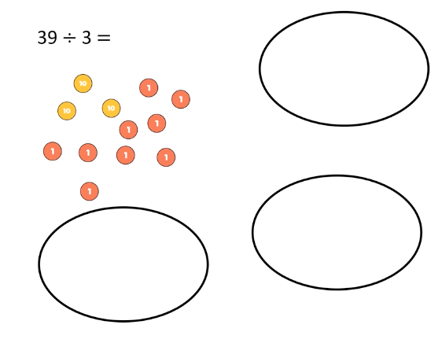

How many did you have in each bubble?

Is it easier to see the solution if the groups are arranged in 10s and 1s?

That is how we think of our numbers when we use the bus stop method. We start by sharing the greatest place value then the smallest.

ANSWER

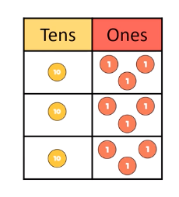
So the answer is 13.

Use this method to solve the following. Choose the section you feel the most confident to answer. Once you can answer 5 of the below with confidence have a go at the challenge questions. They get harder towards to the end, try to do at least 3.

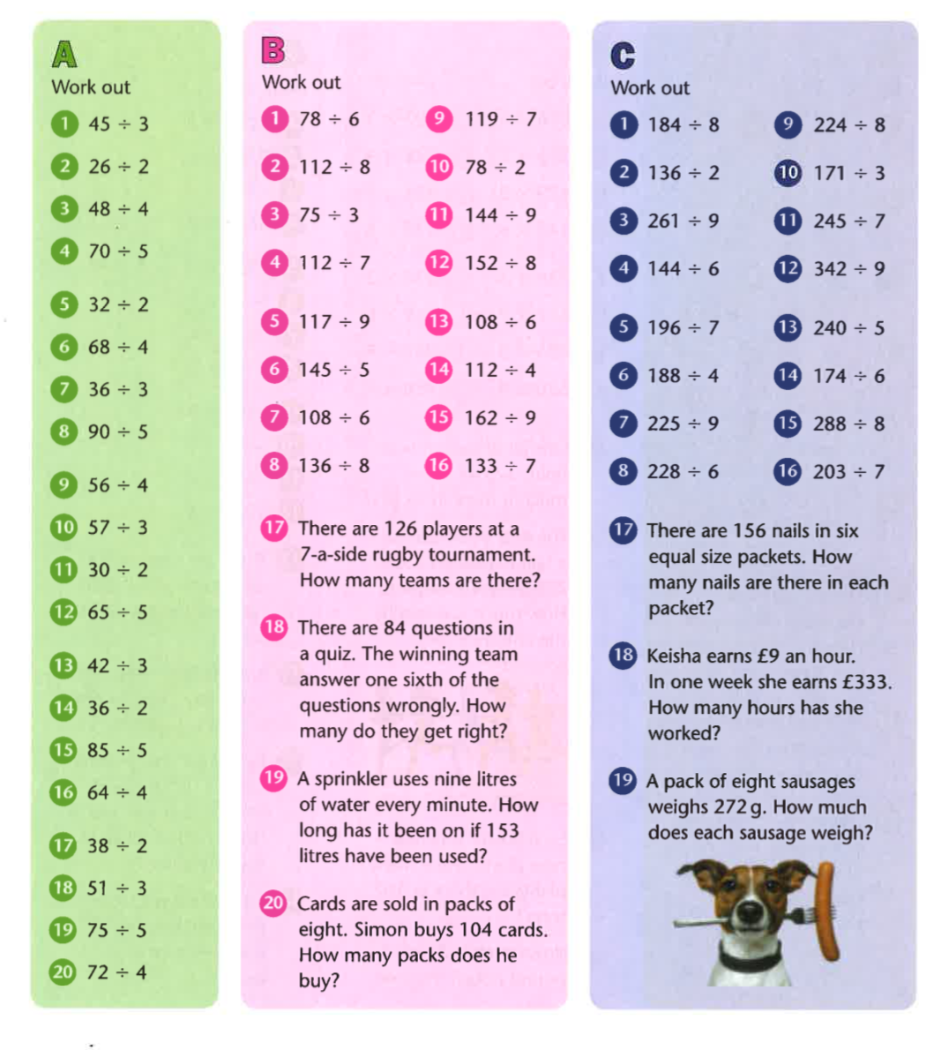

Challenge:

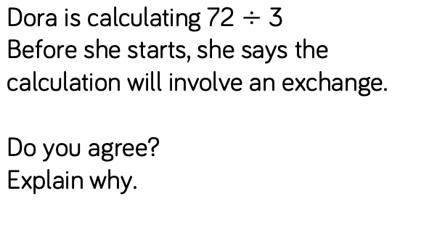
–––––––––––––––––––––––––––––––––––––––––––––––––––––––––––––––––––––––––
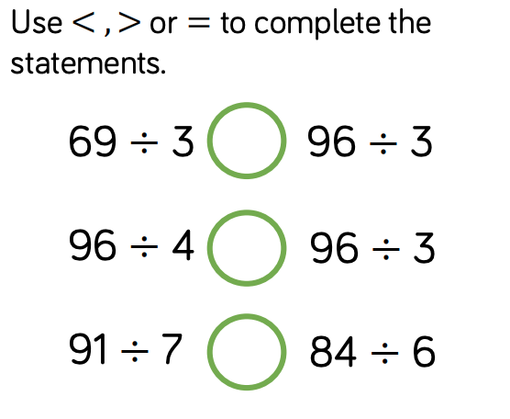
__________________________________________________________________________
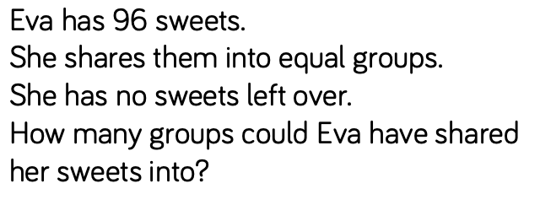
___________________________________________________________________________

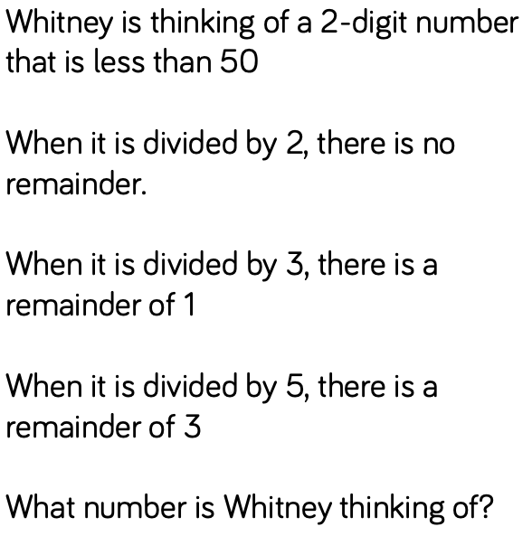
___________________________________________________________________________
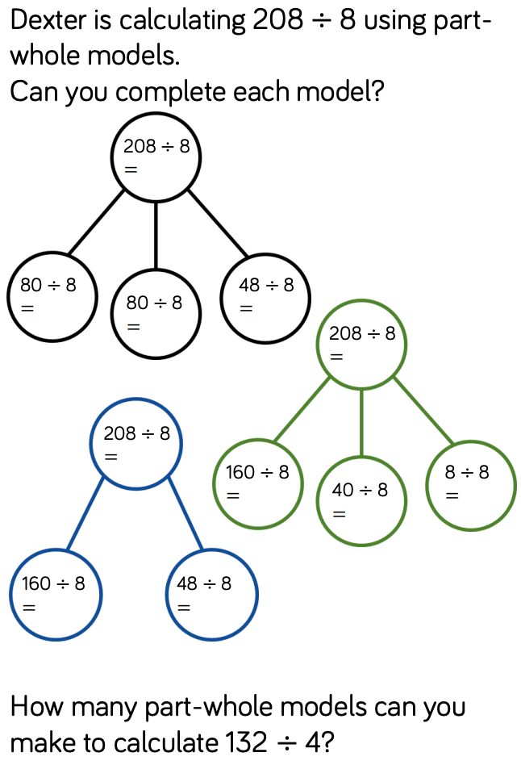

________________________________________________________________________
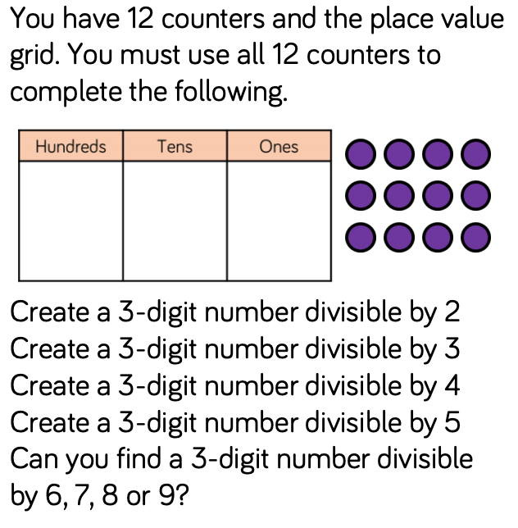

___________________________________________________________________________
ANSWERS

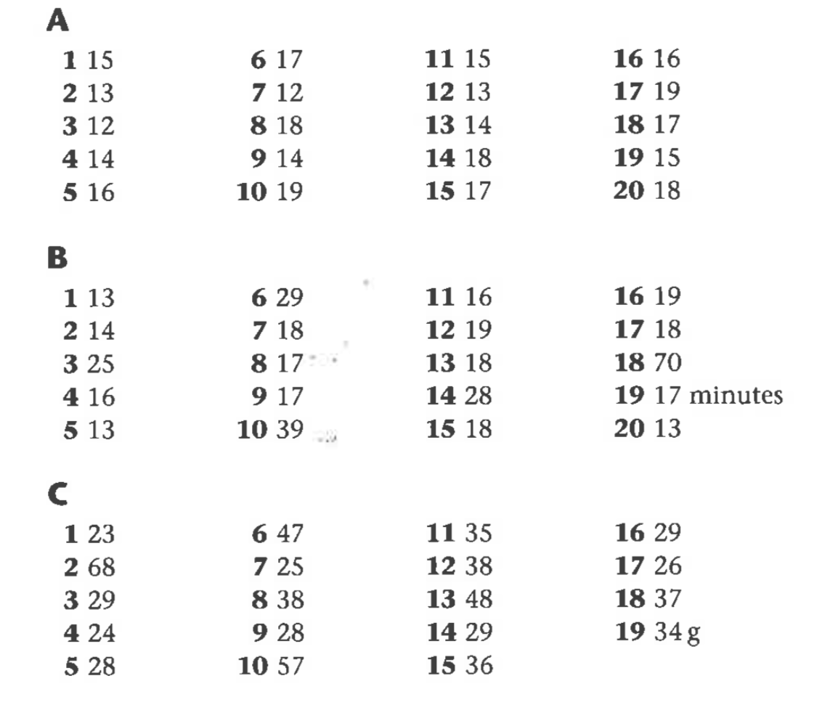

Challenge:

Dora is correct because 70 is not a multiple of 3, so when you divide 7 tens in to 3 groups there is 1 ten remaining which will then be exchanged.

<, <, <

96 shared in to 1 group = 96
96 divided by 2 = 48
96 divided by 3 = 32
96 divided by 4 = 24
96 divided by 6 = 16
96 divided by 8 = 12

Whitney is thinking of 28

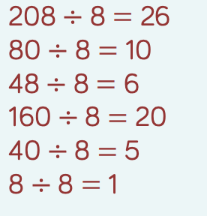

2: any even number
3: and 3 digit number as long as the digits add up to 12, a multiple of 3
4: A number where the last two digits are a multiple of 4
5: Any number with 0 or 5 in the ones

Possible Answers
6: Any even number
7: 714
8: 840
9: impossible

