Maths - 06.01.21

Today we are going to refresh our knowledge on subtraction. Remember to steal from the neighbour if the number you are subtracting from (the top number) is smaller than the number you are subtracting (the bottom number). Choose from A, B or C, C is the hardest. Then complete at least 2 challenge questions.

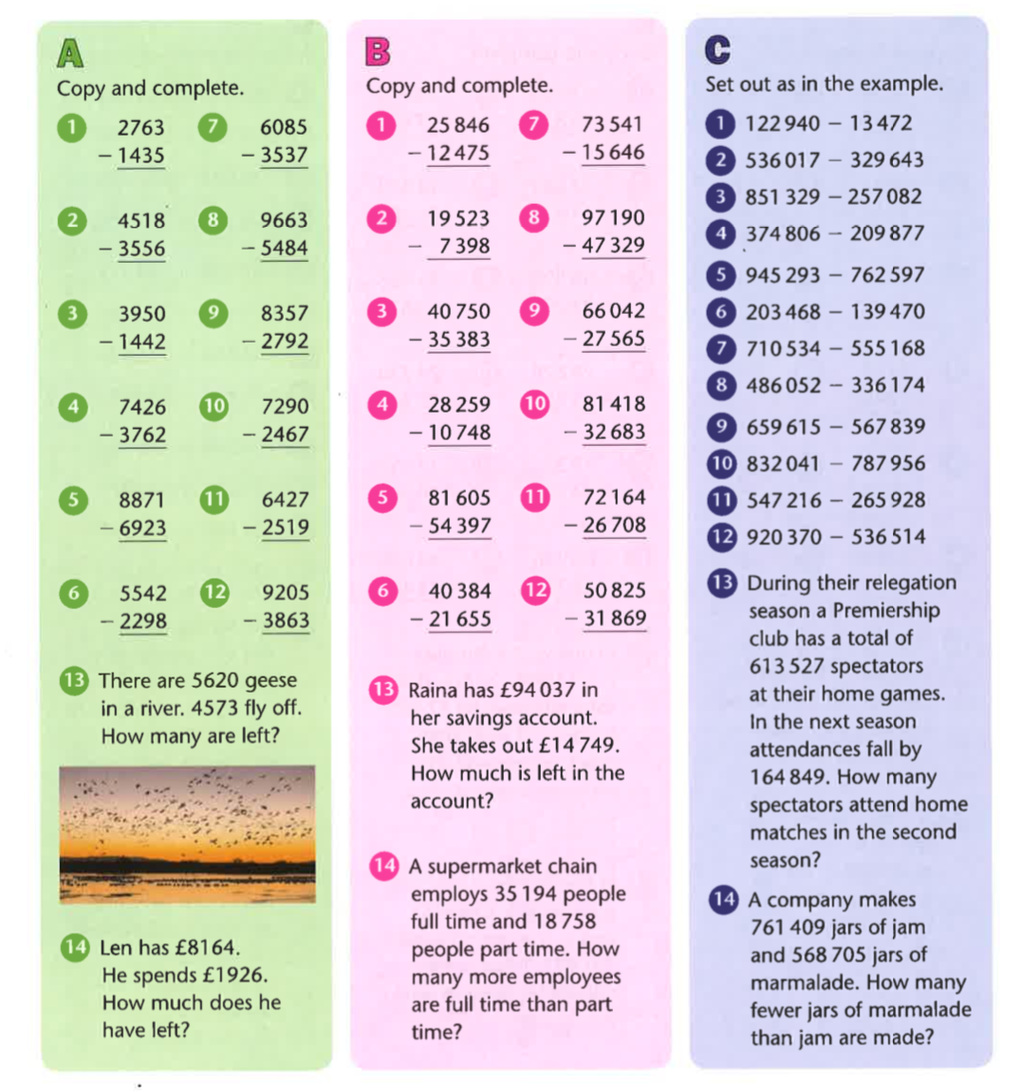

Challenges

