SPaG – Wednesday 6th January 2021

Today we’ll look at prepositions. Prepositions are words that tell us where or when something happens. Please look at the video link attached https://www.bbc.co.uk/bitesize/topics/zwwp8mn/articles/zw38srd.

Preposition Word Mat

about | behind | from | on | toward
above | below | in | onto | under
across | beneath | in front of | on top of | underneath
after | beside | inside | out of | until
against | between | instead of | outside | up
along | by | into | over | upon
among | down | like | past | with
around | during | near | since | within
at | except | of | through | without
before | for | off | to

Look at the text below. How many prepositions can you spot? Underline them as you read.

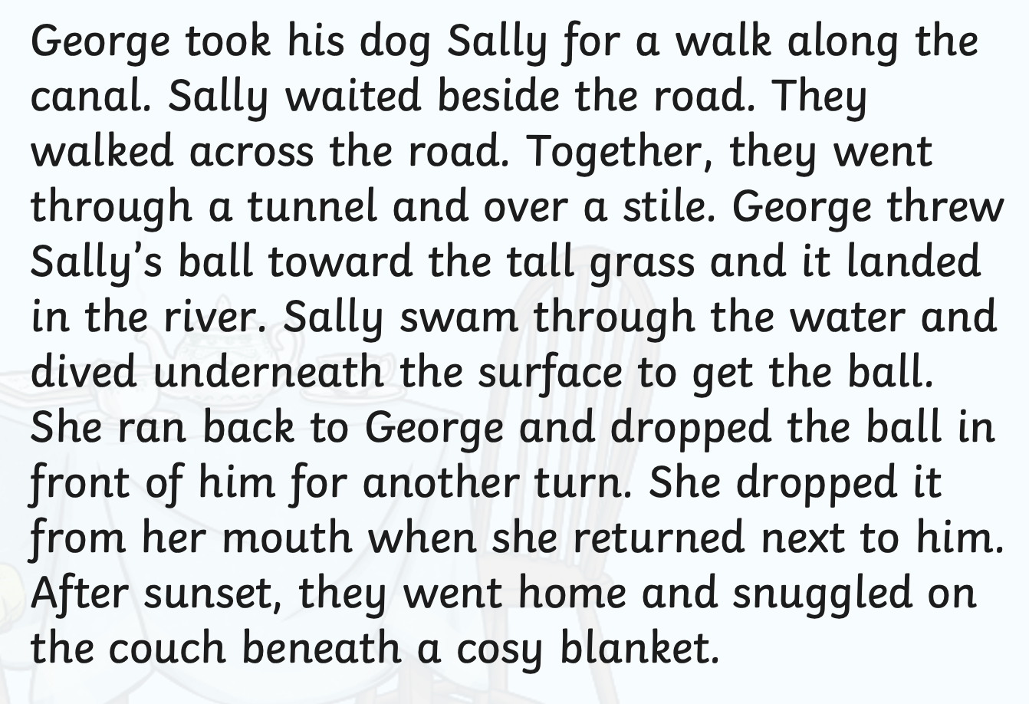

Add prepositions to the following:

The rabbit ran.

A plate of spaghetti.

The old king grumbled.

The sausage was delicious.

There were many Christmas trees to choose from.

