Wednesday 20th January 2021
Science Worksheet

Read the presentation and have a go at answering all the following questions.

Match the type of tooth to the description.

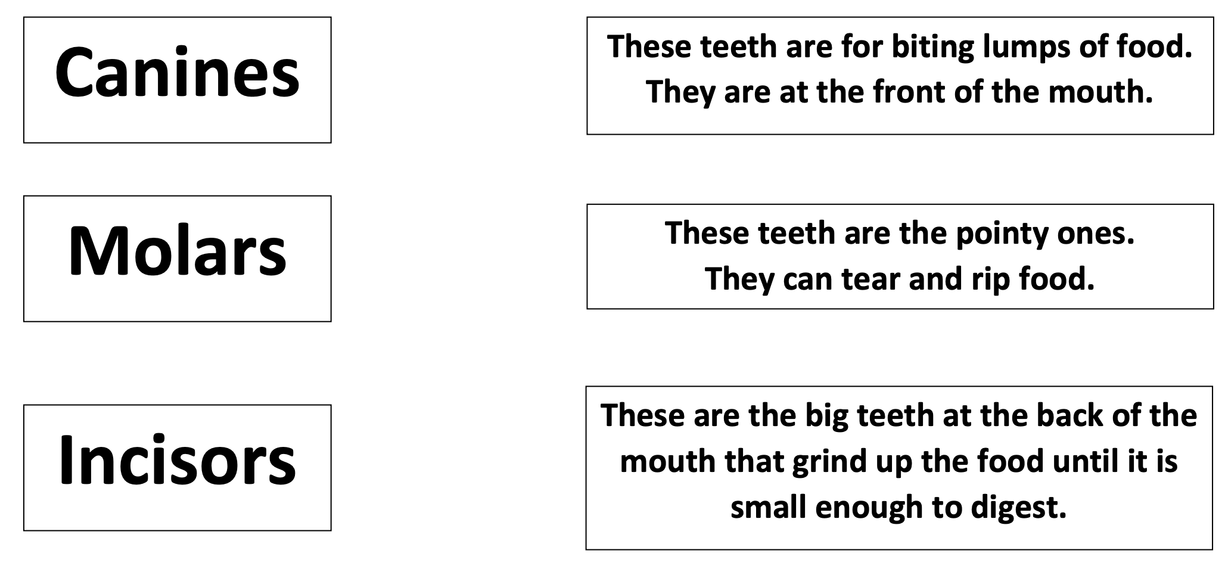
Label the diagram below. If you have access to or can make some play dough then you could make a model of your teeth using a mirror to check you’re correct!

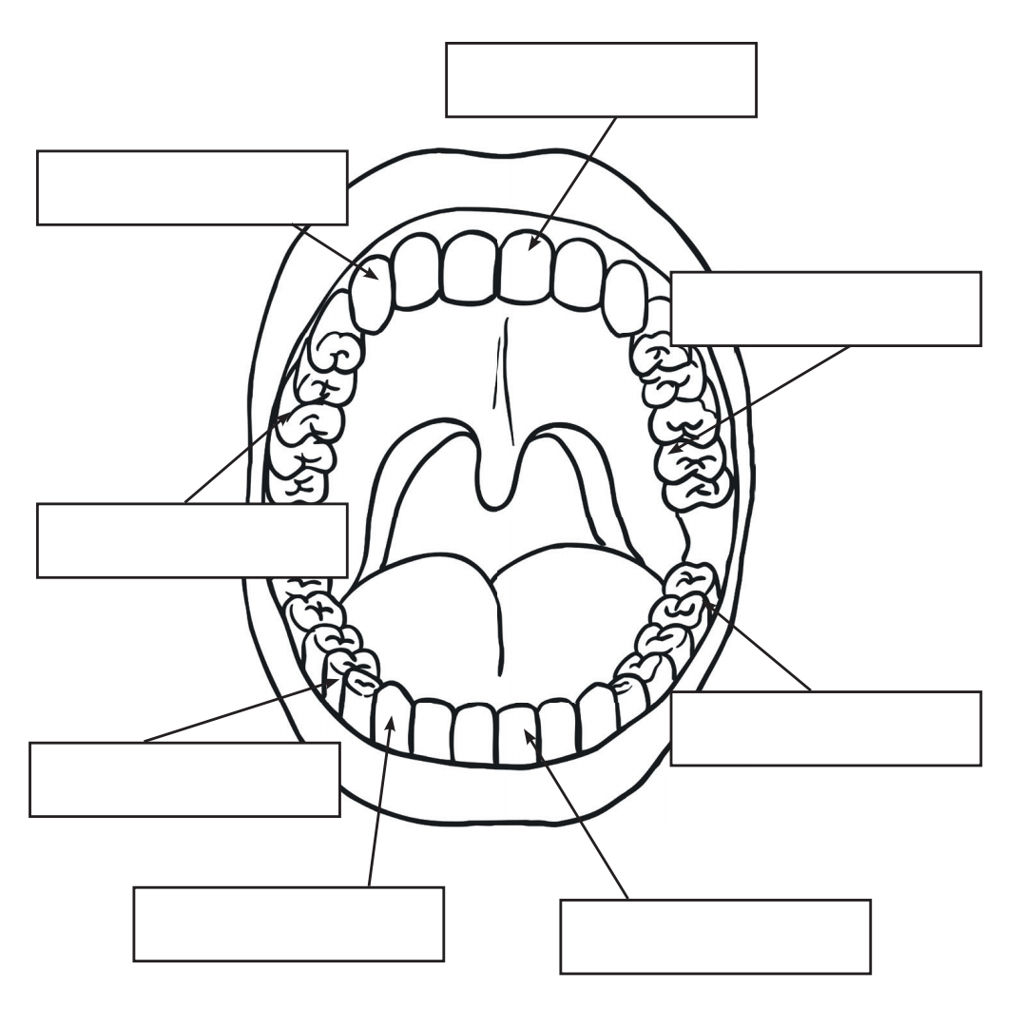
Molar Premolar Incisor Canine

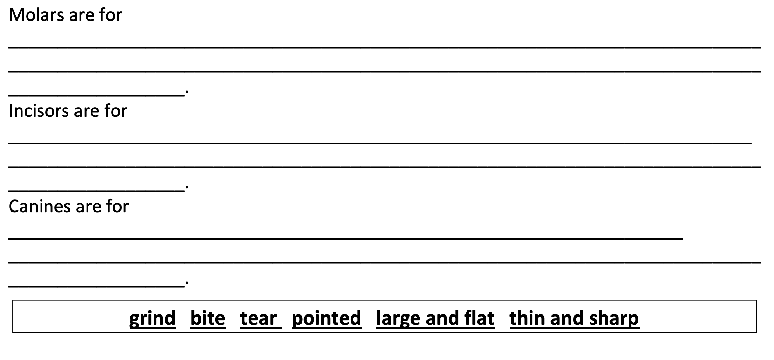

Who’s teeth are these?




