Writing – Monday
Watch this movie and then choose a task to complete.
https://www.youtube.com/watch?v=EJza7j6L9S0
This story is set in the 30s. Harry, the barber, who lives in New York has some prejudiced views. If you are interested in learning about racism in the 1930s, or for a bit of background research, here is a link.
https://www.britannica.com/topic/African-American/African-American-life-during-the-Great-Depression-and-the-New-Deal

Task 1
Write a character description about Harry. Plan your writing first using the checklist below.
Features checklist of character description.
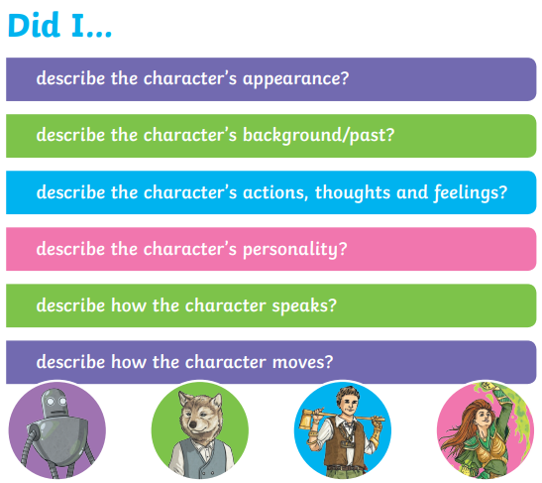
Task 2
Write a description of the setting. Here is a checklist.
