Who was Charles Darwin?

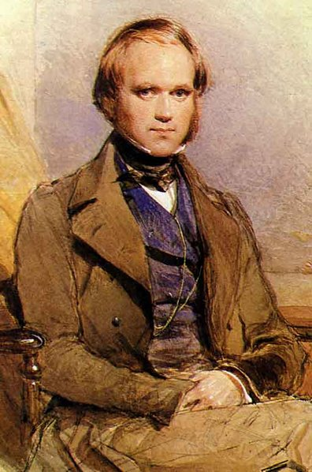
Charles Darwin was an English Scientist, he was born 200 years ago on 12 February 1809. His family was wealthy and Darwin always had plenty of money during his life. As a boy, he hated school but loved playing outdoors and collecting beetles. He and his brother did chemistry experiments in a shed in their garden which they called the ‘lab’.

Darwin went to study medicine at Edinburgh University in Scotland when he was 16. He hated seeing people in pain on the operating table and left after two years. He then went to university in Cambridge. His plan was to work in a church as a vicar. But his real interest was still nature and he loved to be outdoors. At the age of 22, in 1831 Darwin was given the chance to travel the world on a ship called the Beagle.

His job was to observe and record all the plants and animals that he saw during the trip. Darwin explored remote regions so different from the ones he knew. He encountered birds with bright blue feet, sharks with T-shaped heads and oversized tortoises. The trip lasted for five years! He collected thousands of fossils, plants and animals that had never been seen before in Britain.

When he finally returned to England, Darwin had lots of ideas about what he had seen. He set out to explain the way he thought everything in nature was linked together. His BIG idea was that animals and plants were not created by God, but had slowly developed over millions of years. This BIG idea was called the theory of evolution. He spent the next twenty years working on his ideas in his house in Kent, often in his garden. He continued to collect thousands of specimens such as insects and flowers. He spent hours patiently experimenting with the pollen from flowers, for example, and watching cucumber plants climb. He used a microscope and magnifying glasses to study insects and plants. All these experiments helped him to explain why his BIG theory about nature must be right.

Darwin’s most important book was called ‘On the Origin of Species’ which was published in 1859. This changed the way people thought about nature, animals and human beings. Darwin died in 1882 and was buried in Westminster Cathedral, a huge honour. Most people agree that his ideas changed the world.

Questions

- Who is Charles Darwin?

- As a young boy, what did Charles Darwin enjoy collecting?

- At the age of 16, what did Darwin study?

- What was Charles Darwin interested in?

- In 1831 where did Darwin travel to and how did he get there?

- What was Darwin’s job during the trip?

- ‘Darwin explored remote regions’. What does that mean?

- How long did Darwin’s trip last for and what did he find and collect?

- What does the word fossils mean?

- What was Darwin’s big idea?

- Darwin believed that ‘animals and plants were not created by god, but had developed slowly over time’. What do you think?

- What equipment did Darwin use to experiment?

- Why do you think Darwin did the experiments?

- What was his most important book called?

- What do you think ‘survival of the fittest’ means?

- What does the word ‘offspring’ mean?

