Art 24.2
Remember, we have been learning about the countries in the United Kingdom.
The Welsh flag looks like this:
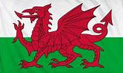
Go to the following web page :
How To Draw A Dragon - Bing video
Have a go at drawing your own dragon. Don’t worry if you find parts hard, just try your best!

