If you need to send your completed work via email, please send to lhumphries@charing.kent.sch.uk

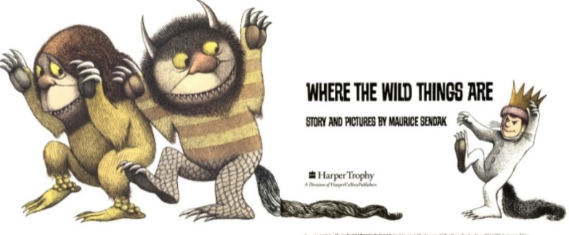
English
For English, we are reading the story Where the Wild Things Are by Maurice Sendak.
Read the story Where the Wild Things Are- https://www.slideshare.net/samsmith_12345/maurice-sendakwherethewildthingsare
https://www.youtube.com/watch?v=ALmNPxNehYE

Writing Task

This week, you are going to continue to write up your own version of the story ‘Where The Wild Things Are’.
For this session, you will only need to focus on the middle of the story which is the second two pictures.

In each picture, you will see some sentences that I have written for you. Your task is to up-level each sentence to make it more detailed and interesting. You can do this by adding interesting sentence starters, adjectives, similes and metaphors.
You will need to write in paragraphs as this will be the next two paragraphs in the story.

Challenge
Extend each paragraph to describe how Max was feeling and by including speech.

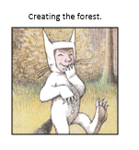  That very night in Max’s room a forest grew.  One by one, trees started to grow until Max’s room was covered in trees.  There were yellow leaves, green leaves, blue leaves and even spiky leaves.  Grass suddenly appeared all over the floor.  Max was feeling very cheeky now! | 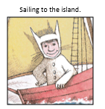  Just then, an ocean tumbled by with a red boat for Max.  Max climbed in and sailed to the island.  He sailed the sea in such delight.  The Wild Things were waiting nearby.

Resources
