If you need to send your completed work via email, please send to lhumphries@charing.kent.sch.uk

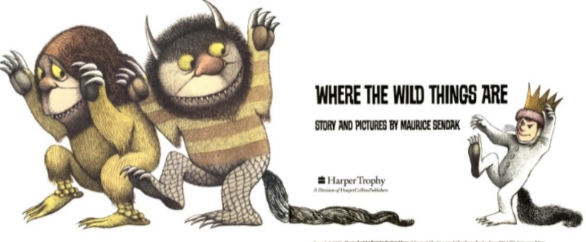
English
For English, we are reading the story Where the Wild Things Are by Maurice Sendak.
Read the story Where the Wild Things Are- https://www.slideshare.net/samsmith_12345/maurice-sendakwherethewildthingsare
https://www.youtube.com/watch?v=ALmNPxNehYE

Writing Task

This week, you are going to continue to write up your own version of the story ‘Where The Wild Things Are’.
For the next two sessions, you will focus on the last two pictures in the story.

You will need to describe what happened, how Max was feeling and you will need to include some speech in each picture. You can read back through the story to magpie some ideas.
Fill in the blanks (_____) and finish the last paragraph on the second picture.
You can use the adjective word bank if you need some ideas.

Challenge

Can you write an alternative ending to the story?
Did something happen to Max when he got home?
Maybe one of the Wild Things went home with Max!

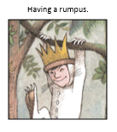  After a while, Max arrived in Wild Thing Land. They roared there _______roars and gnashed their ___________ teeth and they looked very _________.  Max had a plan to trick. He stared into their eyes to scare them. It worked!  “You are the ________ King now,” they shouted.  They all had a _________ time. Max felt so ________. | 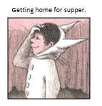  Max could smell _________ foods.  His tummy started to rumble.  He told the wild things that he had to go home.  When he got home, he …

Resources
