Please send your completed work to lhumphries@charing.kent.sch.uk or upload it onto Teams.
English
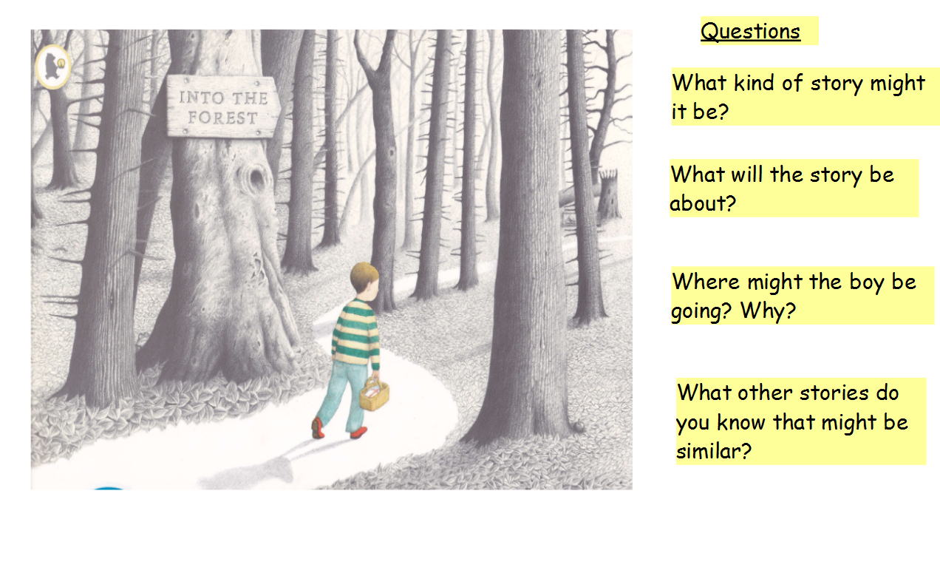
This term, we will be reading the story Into the Forest by Anthony Browne. Before we begin to read the story, I would like you to look carefully at the front cover. What can you see?
Writing Task
- Complete each sentence below to describe what you think this story is going to be about.

I think this story will be about ______________________________________.
The main characters in the story will be _____________ and _______________.
The boy in the picture is walking to __________________________________.
On his journey, the boy will meet ________________ and _________________.

Challenge
How would you feel if you were the boy in the picture and you were walking through the forest and why?

