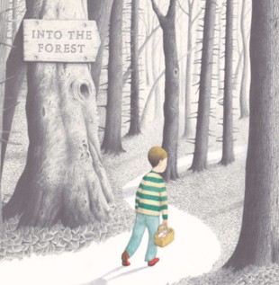
Please send your completed work to lhumphries@charing.kent.sch.uk or upload it onto Teams.
English
This term, we will be reading the story Into the Forest by Anthony Browne.
You can listen to this story being read on the following link:
https://www.youtube.com/watch?v=qjgugbdwvMY

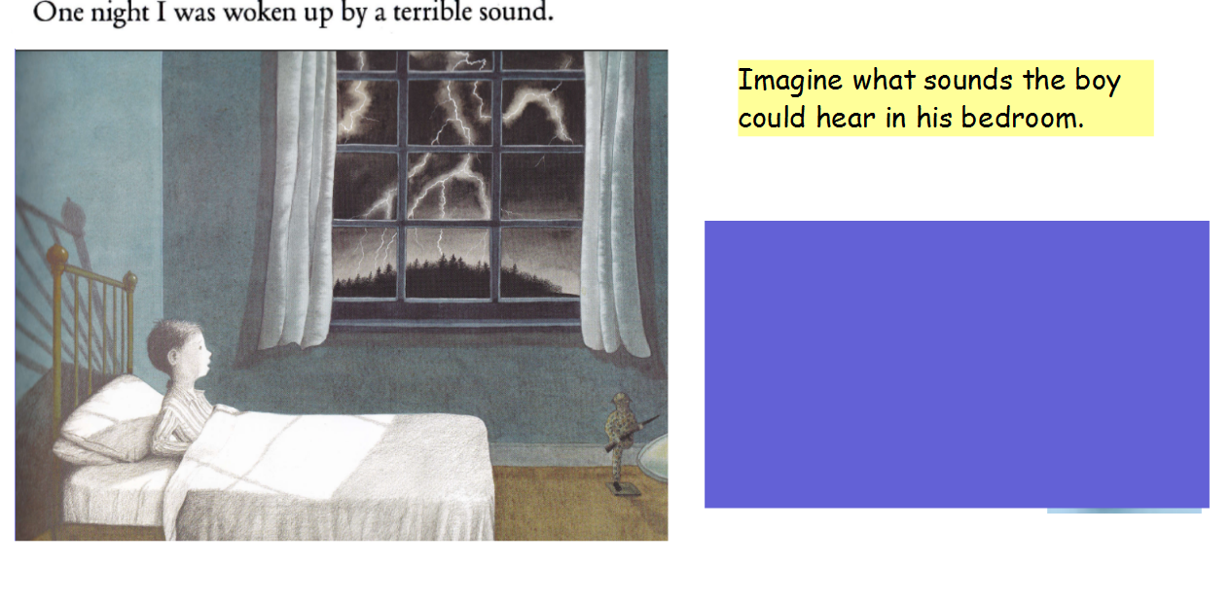
Imagine that you are the boy in the picture and think about what he can see, hear and how he might be feeling. Make a list in the spaces below (you will need to write at least 3 in each list).
See | Hear | Feeling
Example: dark sky

Writing Task
Write a descriptive poem to describe the picture in the book. Use your ideas about what the boy could see, hear and how he might be feeling and extend them to create descriptive lines in your poem.
Example: dark sky
Late one night a dark sky gave me a fright

Poems can have many features (see resources). Read through each feature and include as many as you can in your poem.

You can use my example to magpie some ideas.
Example
Late one night a dark sky __________________________
I felt so anxious and ________
Late one night the wind howled like a__________
I could hear my heart beating _____________
Late one night a ____________________________
It followed with a ________________

Challenge
Can you include a metaphor in your poem?

Resources

