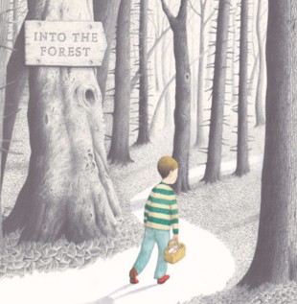
Please send your completed work to lhumphries@charing.kent.sch.uk or upload it onto Teams.
English
This term, we will be reading the story Into the Forest by Anthony Browne.
You can listen to this story being read on the following link:
https://www.youtube.com/watch?v=qjgugbdwvMY

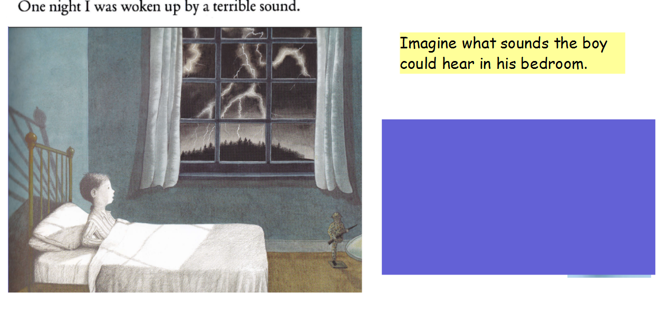
If you have already completed this task yesterday, you do not need to do it again.
Imagine that you are the boy in the picture and think about what he can see, hear and how he might be feeling. Make a list in the spaces below (you will need to write at least 3 in each list).
See | Hear | Feeling
Example: dark sky

Writing Task
Continue to write the next verse in your poem. Once you have finished your poem, you can then edit and improve it.

Complete the lines in the poem below.

Example
Late one night the rain _______ down
It sounded like __________
Late one night a _______ of lightning appeared
I felt ______________________
Late one night the trees _________________
I trembled with __________

Challenge
Can you include rhyme in your poem?

Resources

