If you need to send your completed work via email, please send to lhumphries@charing.kent.sch.uk

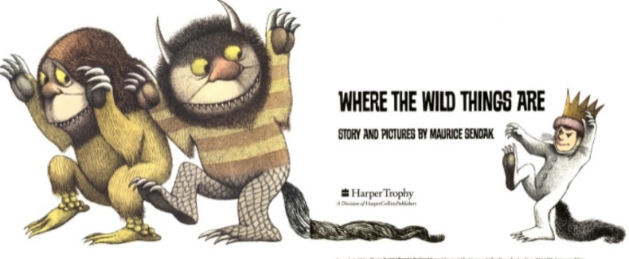
English
For English, we are reading the story Where the Wild Things Are by Maurice Sendak.
Read the story Where the Wild Things Are- https://www.slideshare.net/samsmith_12345/maurice-sendakwherethewildthingsare
https://www.youtube.com/watch?v=ALmNPxNehYE

Writing Task

This week, we are going to be learning to use speech in our writing.

Look at this video to learn how to use inverted commas for speech.
https://www.bbc.co.uk/bitesize/clips/zvftsbk
Read through the Power Point Presentation if you need more support in using inverted commas to write speech.

Task
Write a short conversation between Max and a different character in the story for each picture below. You will need to use inverted commas (“”) and make sure you have used the correct punctuation.
You cannot use the word said. Choose a word which best describes how the character is speaking (see resources). For example, if Max was speaking in a grumpy voice, you may choose to use the word moaned instead of said- “I hate being sent to my room!” moaned Max.
I have completed the first picture for you. Use this to structure your writing for the remaining pictures.

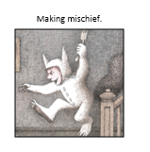  “Ahhh I feel like getting up to mischief!” shouted Max.  “Max, stop making so much noise or you will be sent to your room!” Yelled Mum angrily. | 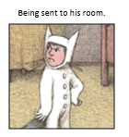
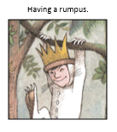 | 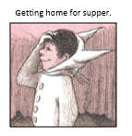

Resources
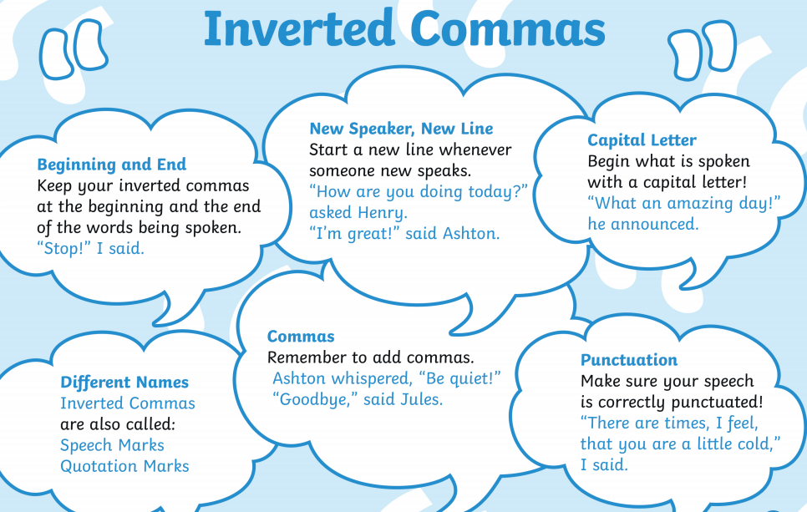

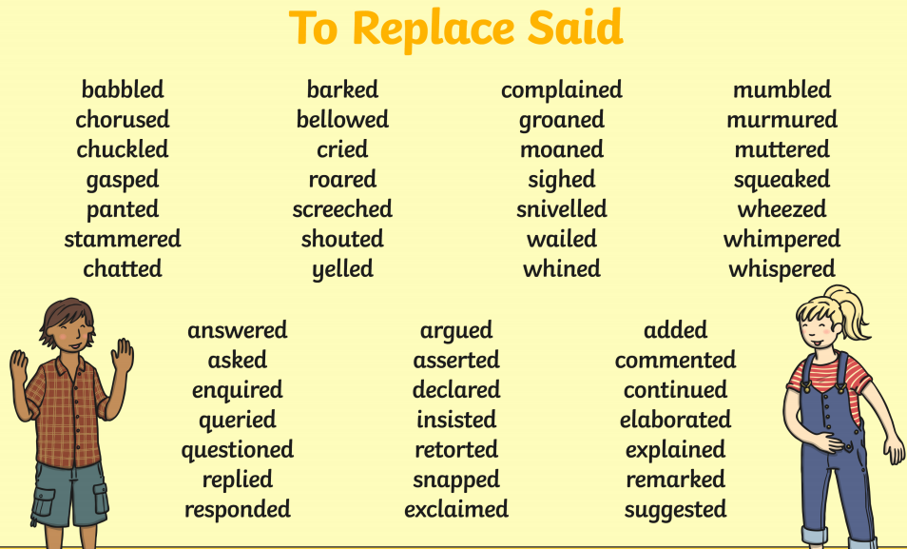

Where the Wild Things Are Word Bank
