If you need to send your completed work via email, please send to lhumphries@charing.kent.sch.uk

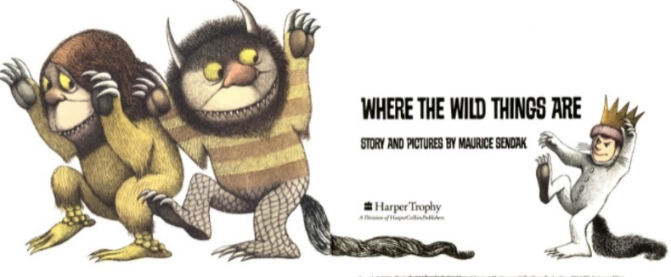
English
For English, we are reading the story Where the Wild Things Are by Maurice Sendak.
Read the story Where the Wild Things Are- https://www.slideshare.net/samsmith_12345/maurice-sendakwherethewildthingsare
https://www.youtube.com/watch?v=ALmNPxNehYE

This piece of work will continue over Thursday and Friday.

Task
You are going to write up your own version of the story ‘Where The Wild Things Are’.
You will only need to focus on the beginning of the story which is the first two pictures. You will need to describe what happened, how Max felt and you will need to include direct speech.

You need to fill in the blanks (____________) and finish the sentence (…).

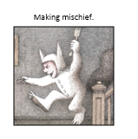 | 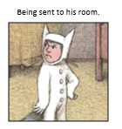

One long afternoon, Max began to feel extremely_________. Suddenly, he got an urge. An urge to get up to_______.
Max ran down the stairs making mischief
“If you don’t stop, you will be sent to your room!” Mum shouted. Max didn’t stop! “Right, up you go!” ________ Mum. Max was sent to his room.

Feeling moody, Max…
Max mumbled, “______________________________.”

Resources
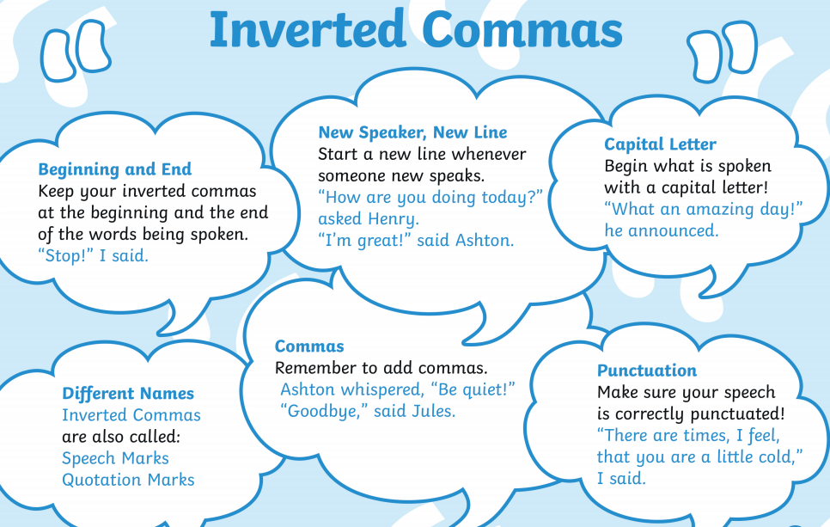

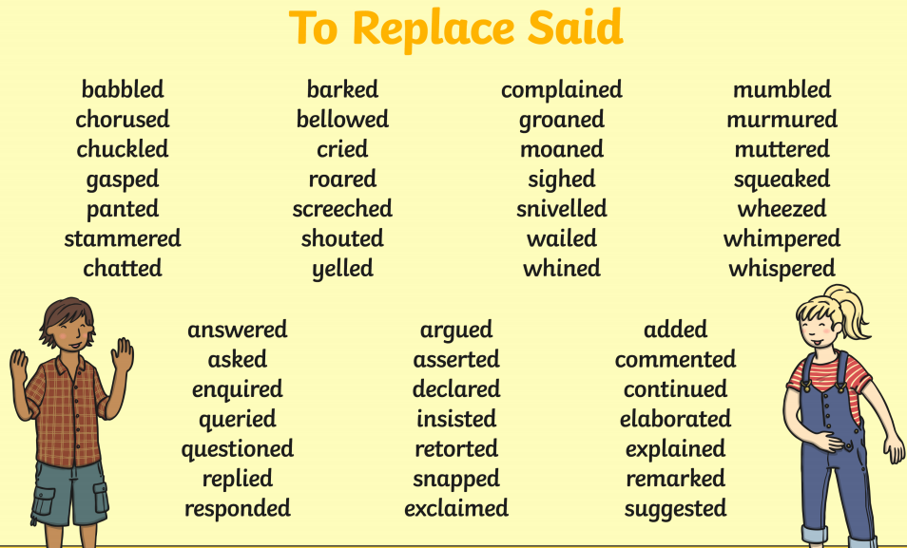

Where the Wild Things Are Word Bank
