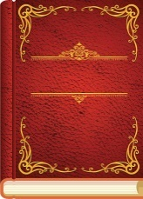
Classic Comprehension Texts

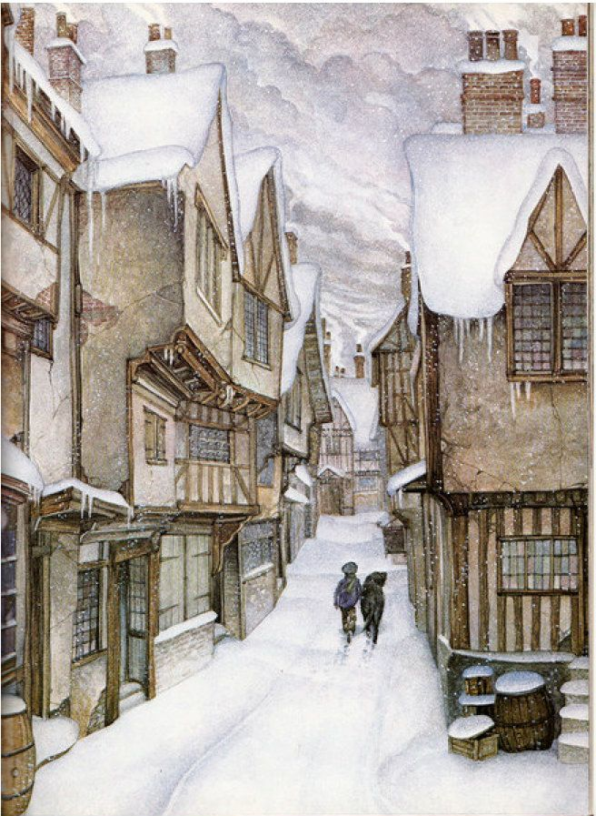

Fair’s Fair
by Leon Garfield

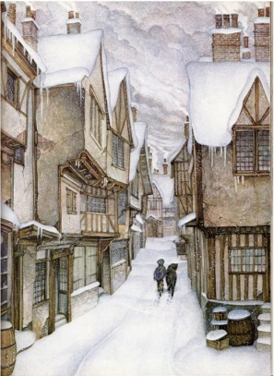
From Fair’s Fair
Leon Garfield
Jackson was thin, small and ugly and stank like a drain. He got his living by running errands, holding horses and doing a bit of scrubbing on the side. And when he had nothing better to do he always sat on the same doorstep at the back of Paddy’s Goose, which was at the worst end of the worst street in the worst part of town.
He was called Jackson because his father might have been a sailor; Jack being a fond name for a sailor in the streets round Paddy’s Goose; but nobody knew for sure. He had no mother either, so there was none who would have missed him if he had fallen down a hole in the road. And nobody did miss him when he vanished one day and was never seen or heard of again.
It happened when Christmas was coming on- about a week before. Dreadful weather as hard and bitter as a quarrel. Dreadful weather with snowflakes fighting in the wind and milk freezing in the pail.

