P.E.
You can choose one of the following options
- Enjoy some Yoga exercise and mindfulness with Cosmic Yoga on YouTube.
https://www.youtube.com/playlist?list=PL8snGkhBF7nj0XY4DQbm203LNMQvbnPyw
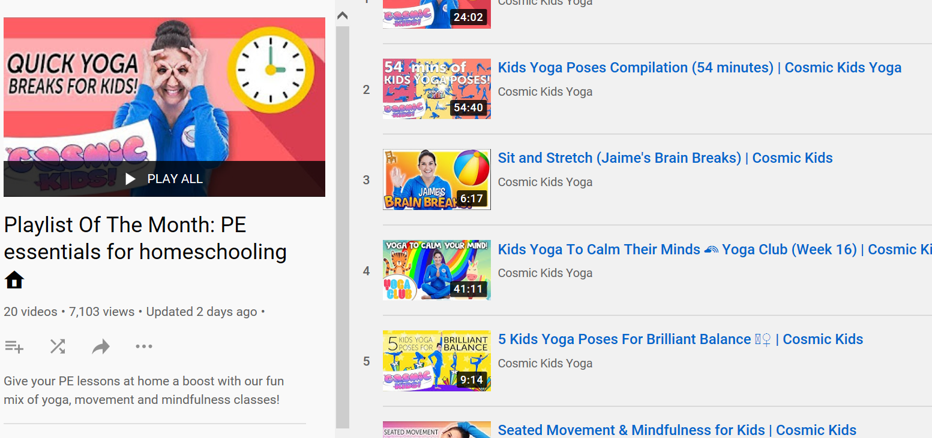

- Join Joe Wicks (The Body Coach) for a live online P.E. session.
https://www.youtube.com/results?search_query=P.E.+Joe+Wicks

