P.E.- You can choose one of the following options
- Find the Cosmic Yoga channel on YouTube and enjoy some Yoga exercise and mindfulness.
https://www.youtube.com/playlist?list=PL8snGkhBF7nj0XY4DQbm203LNMQvbnPyw
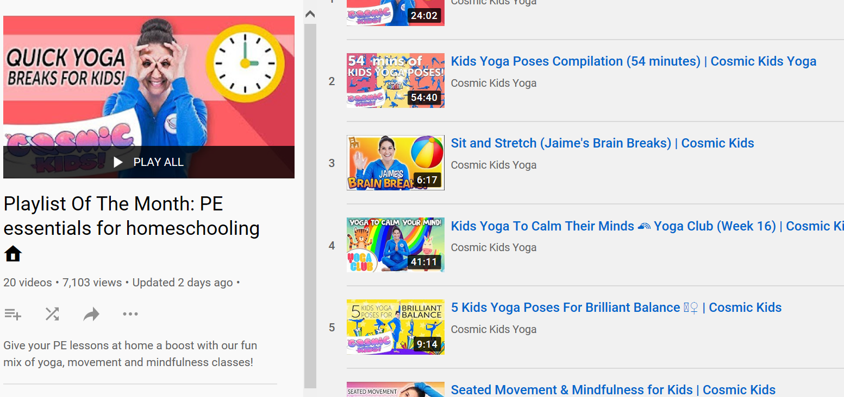

- Find Joe Wicks (The Body Coach) for a live online P.E. session.
https://www.youtube.com/results?search_query=P.E.+Joe+Wicks

- If you have football you could try this P.E. game.
