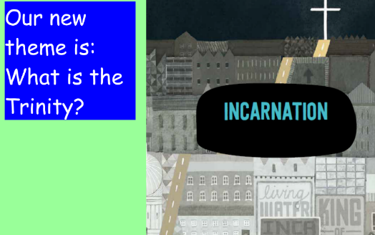**R.E.**

**If you need to send your completed work via email, please send to lhumphries@charing.kent.sch.uk**

This week we are going to learn about how Christians show the Holy Trinity in their every day lives.





It asks God to be with the people who hear the prayer.



For Christians this sense of God being with them, all around them and in their daily lives is part of believing in God the Holy Spirit.

**Task**

**Challenge**

**Why did you choose this item as a gift and how does it show the Holy Trinity?**

**Look at some of the gift ideas below.**

