Please send your completed work to lhumphries@charing.kent.sch.uk or upload it onto Teams.
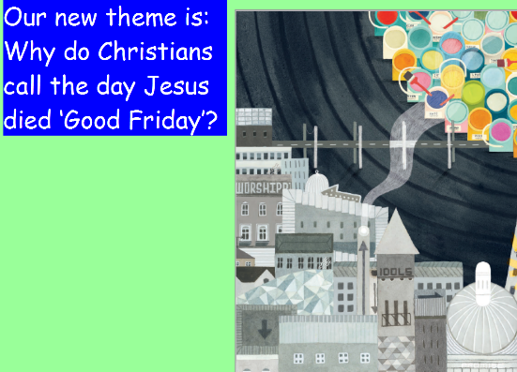
R.E.
This term we are learning about why Christians call the day Jesus died ‘Good Friday’.
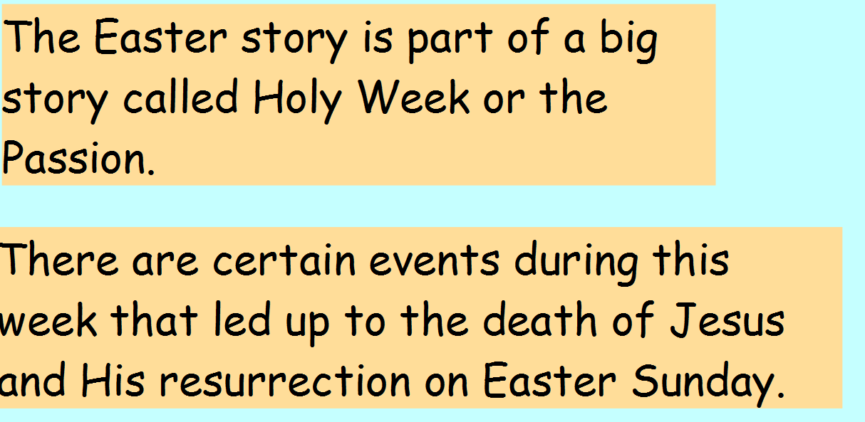

Activity 1: Work through the PowerPoint Presentation on Holy Week
Activity 2: Arrange the pictures to retell the story of Holy Week (see picture below).
Choose how you want to do this:
- Move the pictures into place on the word document (click the mouse, hold and drag the picture).
- Print the pictures, arrange them into order and take a photo.
- Draw and label the pictures and take a photo.

Challenge
What part do you think was the scariest for Jesus? Why?

