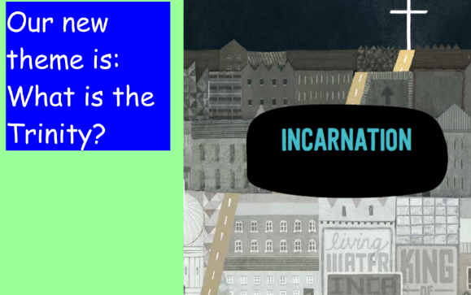
R.E.
If you need to send your completed work via email, please send to lhumphries@charing.kent.sch.uk
This week we are going to learn about how the Trinity is referred to in the Bible.
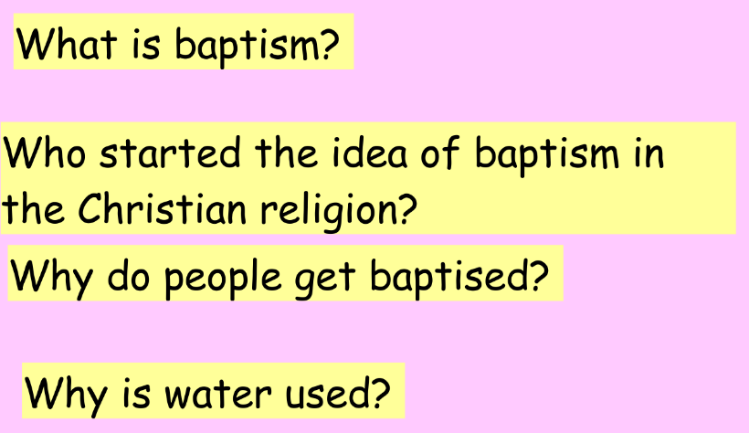
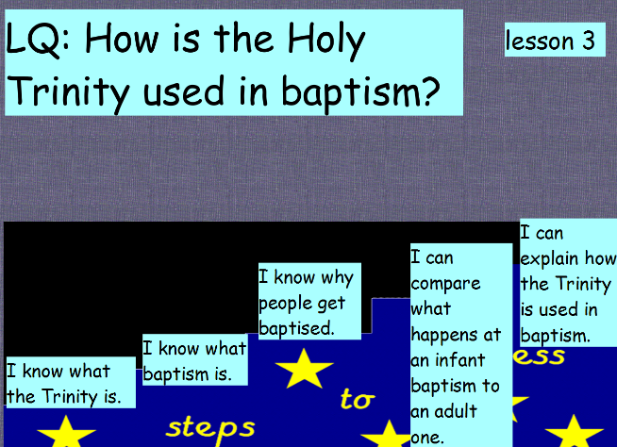

What is baptism? A ceremony to allow the person to join the Christian community.
Who started the idea of baptism in the Christian religion? John the Baptist.
Why do people get baptised? To join Christianity- to show they have washed away their sins and given their life to God.
Why is water used? It helps to clean but also seen by Christians as a metaphor for death, burial and resurrection into a new life- like Jesus.

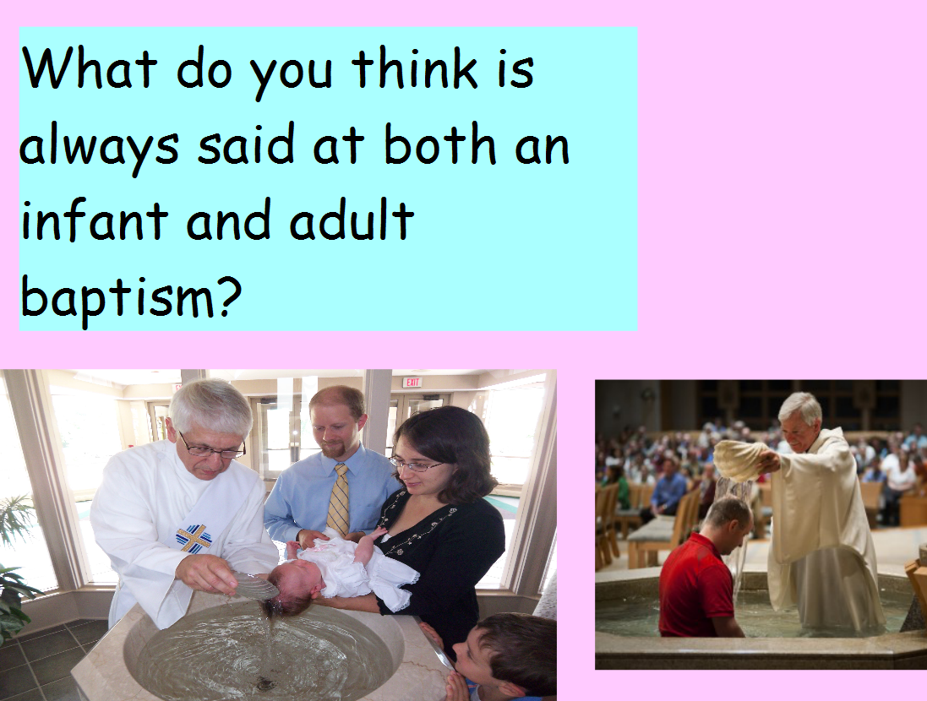
The Trinity! God the Father, God the Son, God the Holy Spirit.
Watch this video of a baptism.
http://www.bbc.co.uk/programmes/p02mwy4d
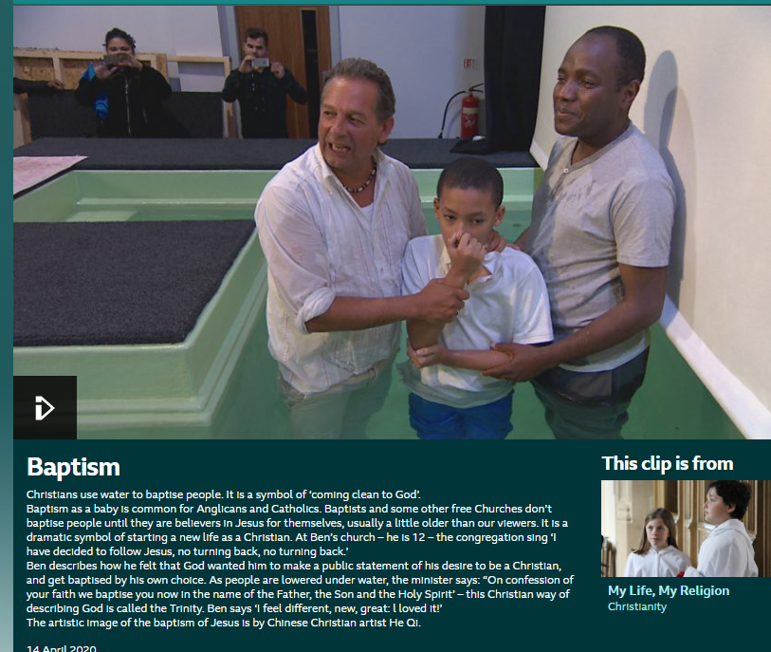

Task (choose activity A or B)
Activity A: Act out an infant baptism- You can take a photo and upload it onto Teams or send it via email.
Activity B: Draw and label a picture of an infant baptism.

What might they say?
How might the parents feel?
What does this now mean for the baby and the adults?
How might the Reverend feel?

