Rabbits Home Learning
Tuesday 9th February

This week it’s all about cats!
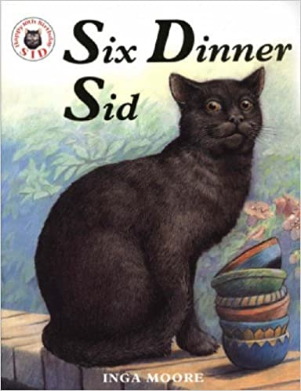
https://www.youtube.com/watch?v=3XAdTJCtgTs
How many dinners does Sid have?
Can you remember what he has for his different dinners?
Where does Sid like to sleep in his different houses?
How many spoonfuls of medicine did Sid have?

How did his owners find out he was living in six different houses?
RWI
Can you match up the words to the pictures on the sheet attached?
Maths
Have a go at the ‘find 6’ challenge pdf attached. As an extra challenge…
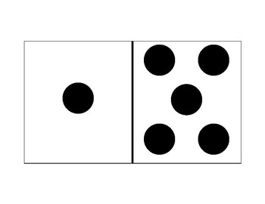
This domino shows 6 spots in total.
How many other ways could you show spots to make 6 in total?
Can you draw and colour in the spots on the attached sheet?
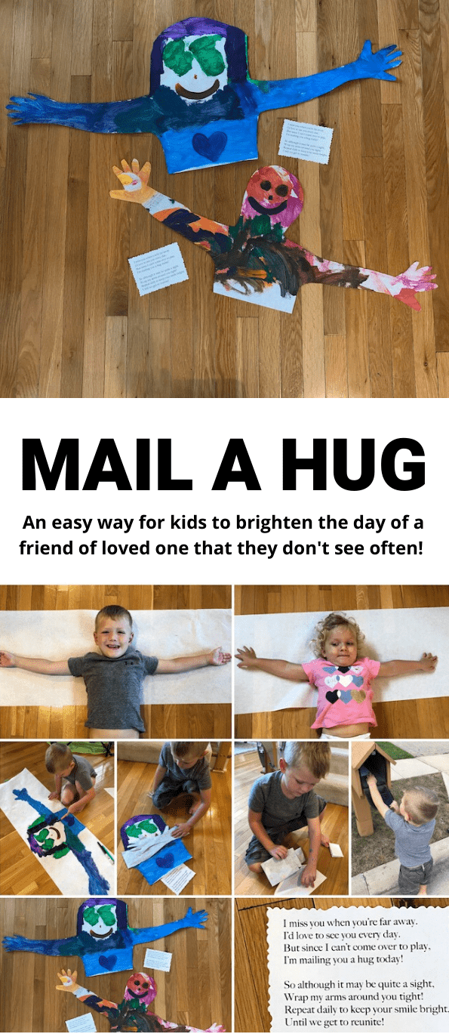
You don’t need to mail it…. Take a photo and send it to someone you love!
Cats
https://www.youtube.com/watch?v=SSo5UHPm76Q
This is a short clip about a cat. What breed of cat is it?
Do you know what cats eat and drink and how you look after them?

Now watch any episode from ‘My Pet and Me’.
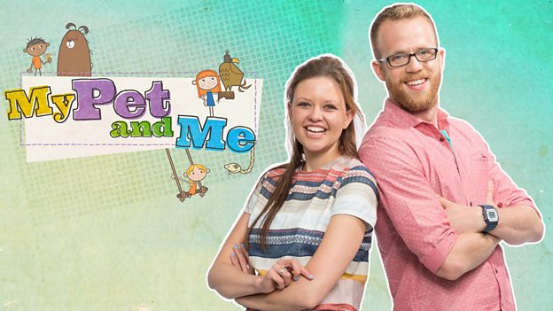
https://www.bbc.co.uk/iplayer/episodes/b06r15z2/my-pet-and-me

