Rabbits Home Learning
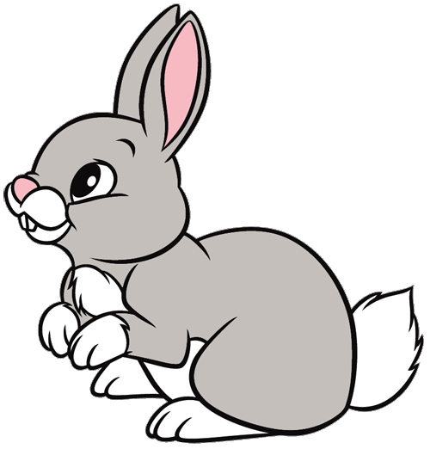
Friday 12th February

To finish off our learning about animals…
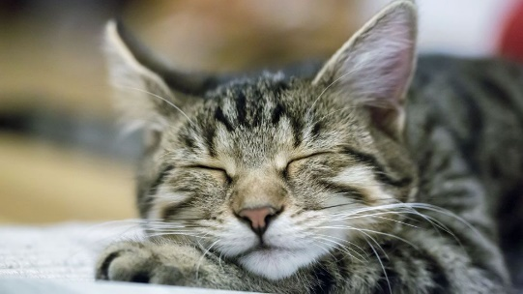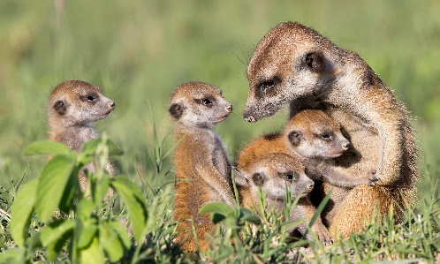
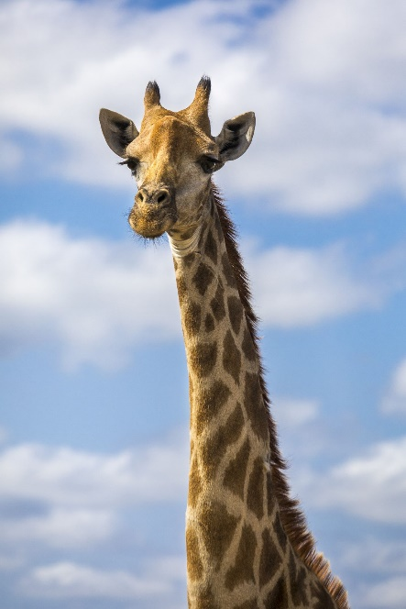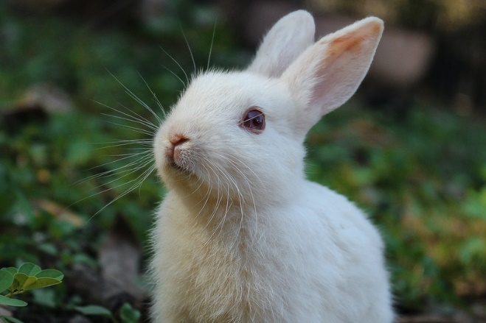
We have looked at wild animals and pets.
Choose your favourite pet or wild animal. Make a poster, model, picture or video presentation about your animal. You could even dress up, get your face painted and have your photo taken!

Have a lovely week next week. I look forward to seeing you all after the break.
Maths challenge and phonics sheet attached if you would like to use them today.
Thanks for all your hard work and enthusiasm.
Well done Rabbits!

