Rabbits Home Learning

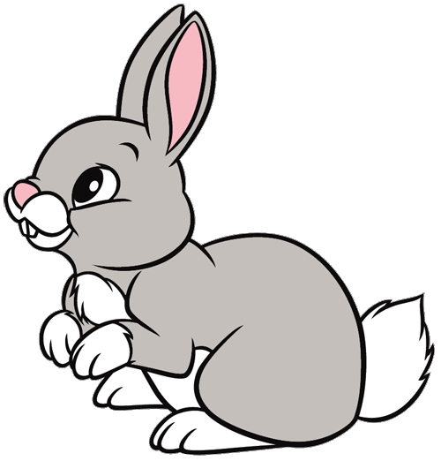

Tuesday 2nd February

English

This week it’s all about dogs!

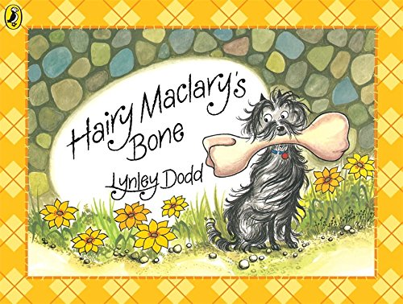

Animated short film of the story.

<https://www.youtube.com/watch?v=Xj9k3CIkUKE>

Make your own character stick puppets using the pictures attached. Can you retell the story from yesterday and the one from today?

What about making up your own story about Hairy Maclary?

RWI

Fred talk the words below and match them to the pictures.

The sheet is attached.

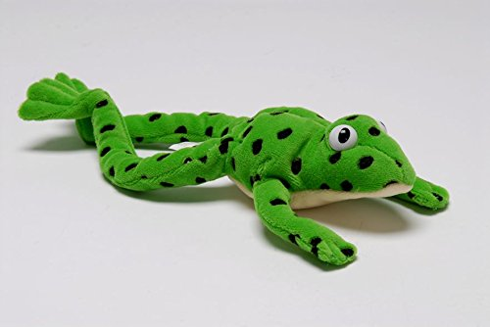

Maths

Please use the attached PDF for today’s maths challenges relating to ‘capacity’, comparing full and empty.

Then have a go at the worksheet attached.

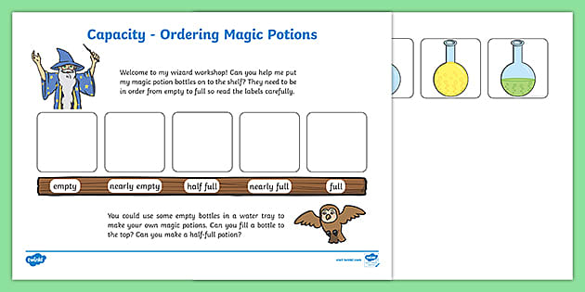

Please can you save a toilet roll tube for later in the week.

