Rabbits Home Learning
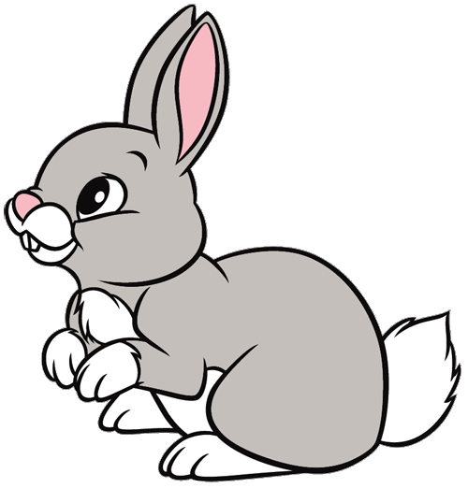
Monday 22nd February
Welcome back Rabbits!
This term our topic is called…. ‘Under the Sea’

Look closely at the picture. How many things can you name?

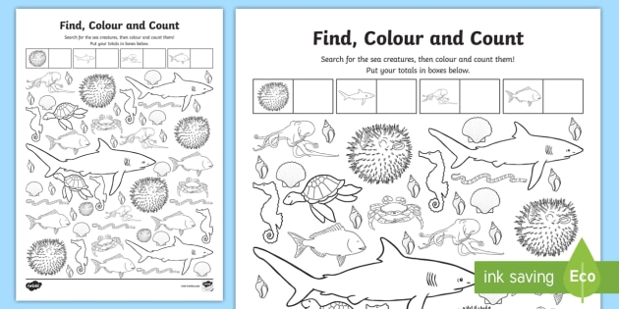
Use the attached sheet to count the sea creatures.

Our story this week is….
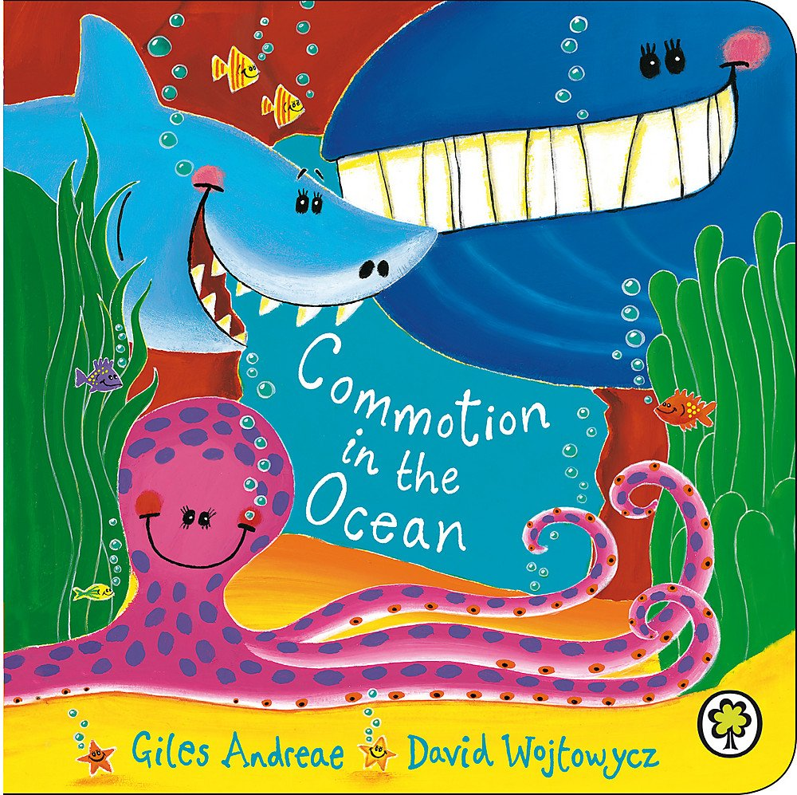
https://www.youtube.com/watch?v=9pRhgZ8Jffs

Can you remember all the sea creatures in the book?
Use the pdf attached (or create your own) to make your own under the sea scene.
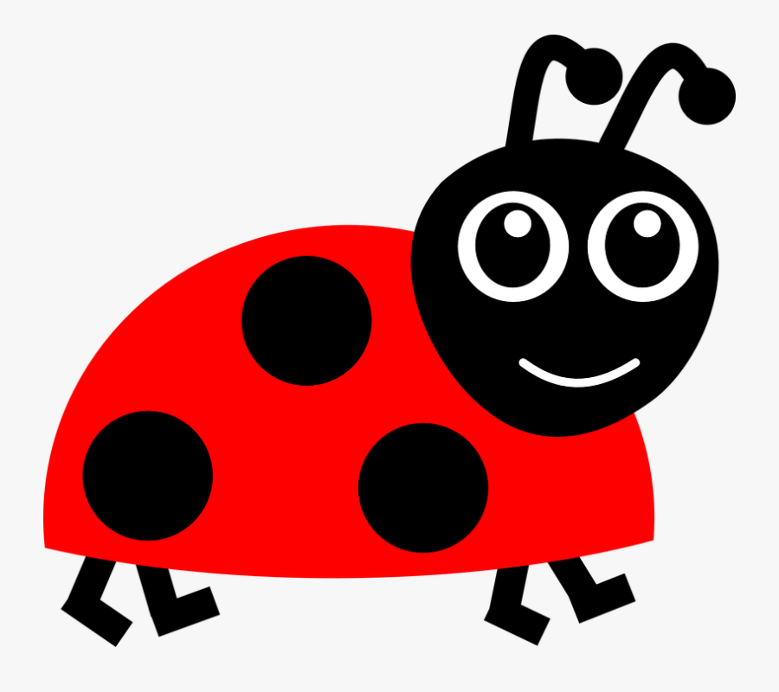
Maths

Try the ladybird matching pairs game we tried today.
You can even make your own ladybird cards and play again.

