Rabbits Home Learning
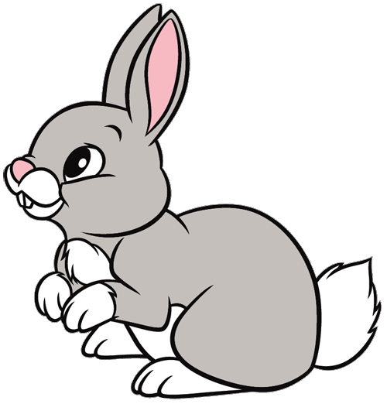
Tuesday 23rd February
This term our topic is called…. ‘Under the Sea’
Our story this week is….
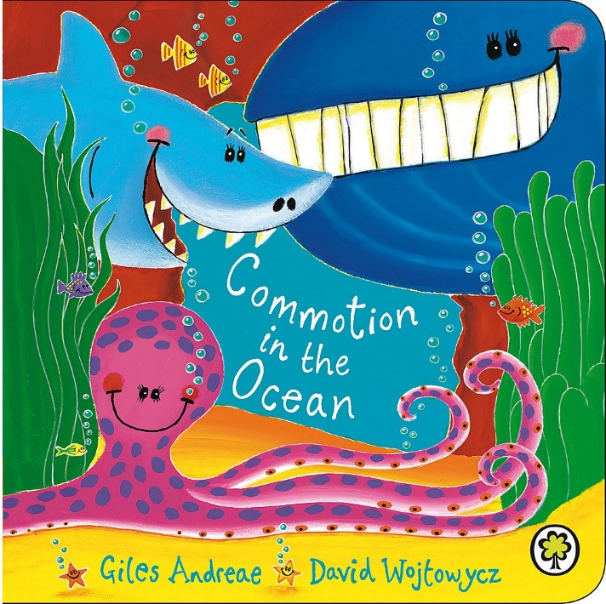
https://www.youtube.com/watch?v=9pRhgZ8Jffs

RWI
There are three activities to choose from today.
If you sometimes find RWI a bit tricky choose activity 1. Choose activity 2 if you know most of your speedy sounds and choose activity 3 if you know all your special friends. You can try two activities if you want to.
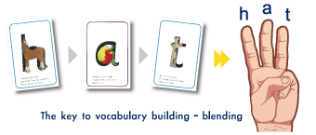

Underwater handprints
Try making some handprint fish today. I remember how much you all loved painting your hands, even when you weren’t supposed to be!!!
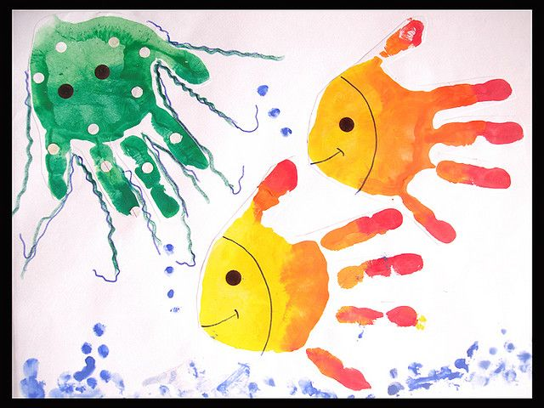
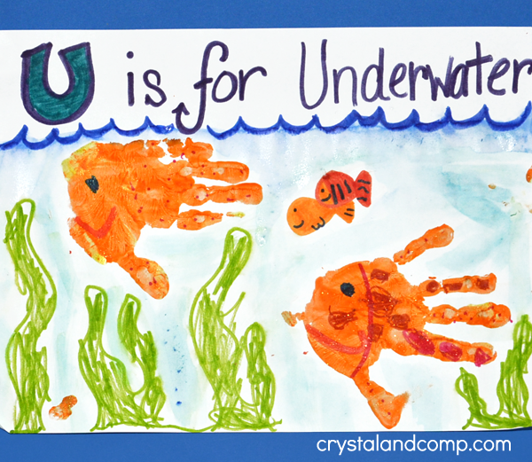

Maths
Today’s learning was all about making pairs. Can you ask an adult to get a big pile of sock? Can you match them into pairs? How long did it take you? Are there any leftover or are they all in equal groups?
How many pairs did you make?

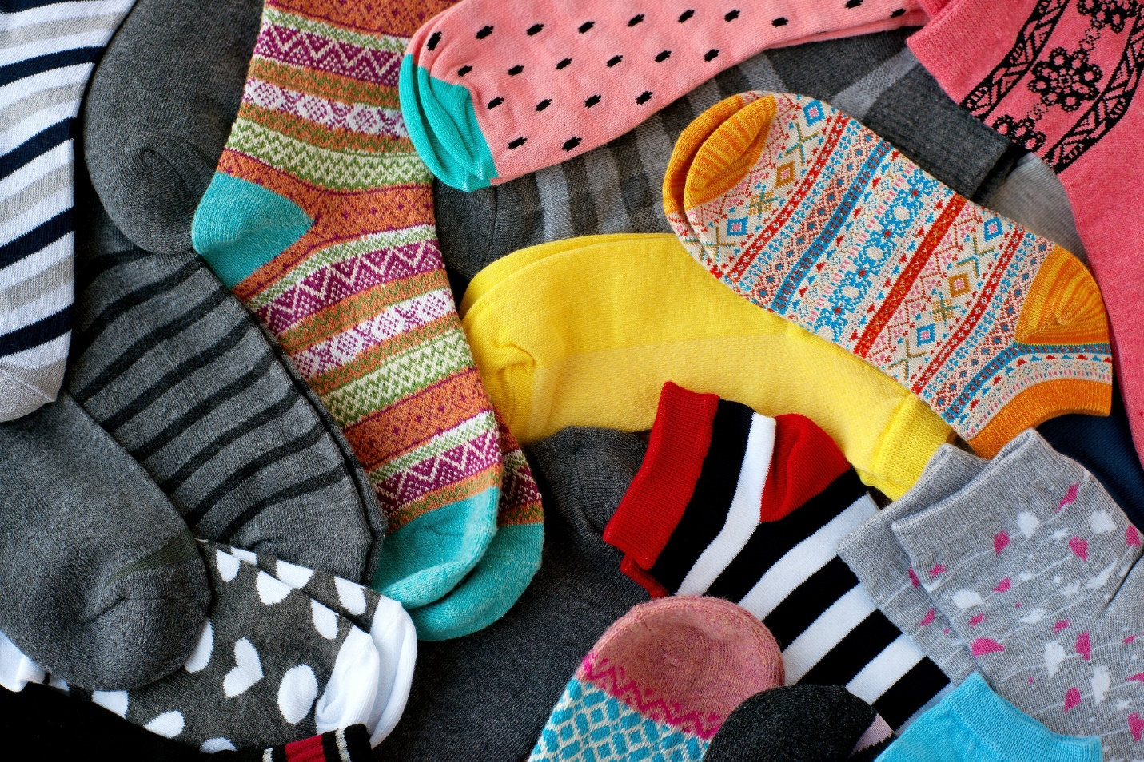

Have a go at the natural objects activity I have attached too.
What things can you think of which come in pairs?
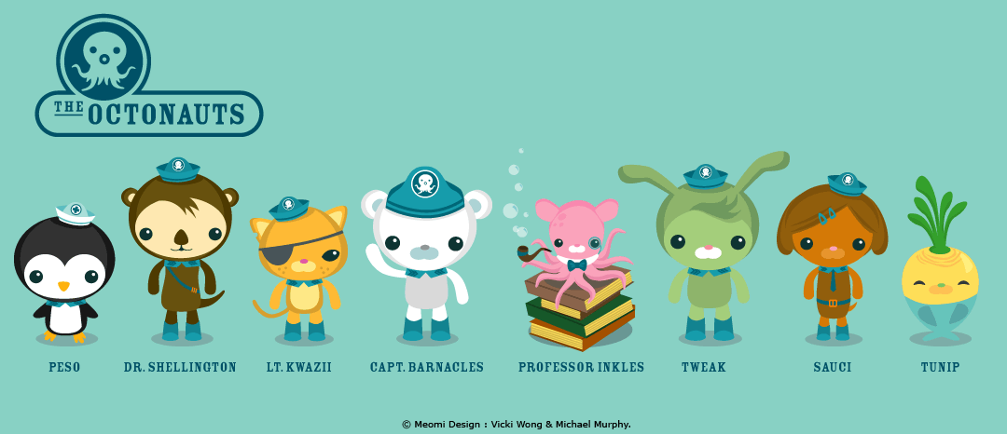
Watch this Octonauts episode about a crab.
https://www.bbc.co.uk/iplayer/episode/b00vt7d3/octonauts-series-1-25-the-decorator-crab

Or find it on youtube.
https://www.youtube.com/watch?v=Fa9f9XZnfSQ
