Rabbits Home Learning
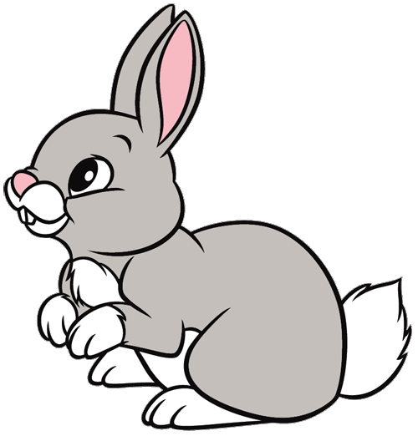
Wednesday 24th February

Look at these two photos.
Do you know what times of the year these photos show?

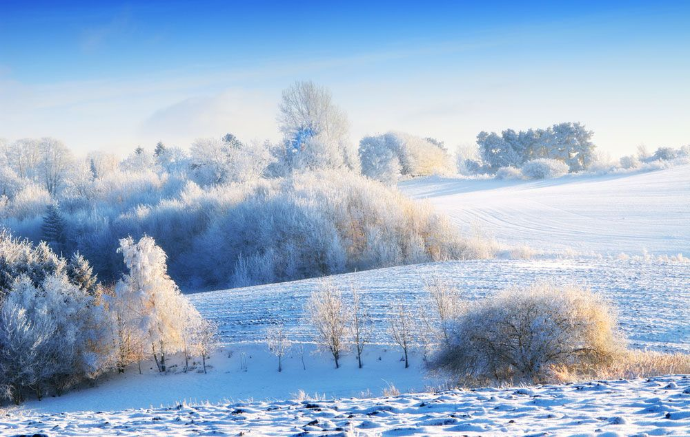
One shows Winter and one shows Spring, which one is which?

Spring starts on the 20th March but there are signs we can see outside that Spring is coming.
Can you go outside today and find signs that Spring is coming?
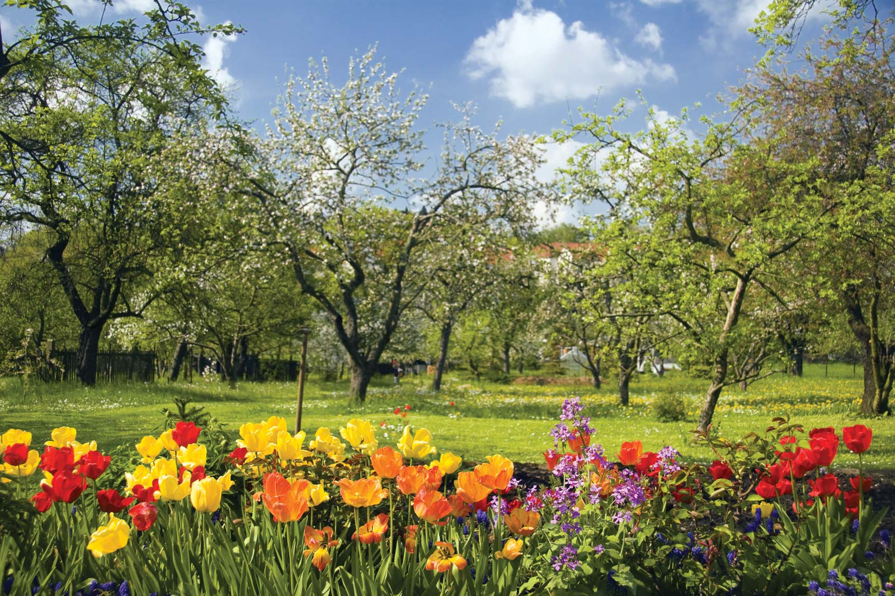
Here is a list of some things to look for…
- Spring flowers (daffodil, snow drop or crocus)
- Sunshine
- Warmer temperatures (although not warm enough to only wear a t-shirt just yet!)
- New buds on plants and trees
- Bees or butterflies (it’s unusual just yet, but we saw a bee at the weekend!)
- Lambs
Did you find any other signs?
Draw a picture or take photos of the things you find.
Enjoy being outside today and play, discover, investigate and notice the world around you.

And if you finish all of that watch an episode of Number Blocks or The Octonauts.

