Rabbits Home Learning
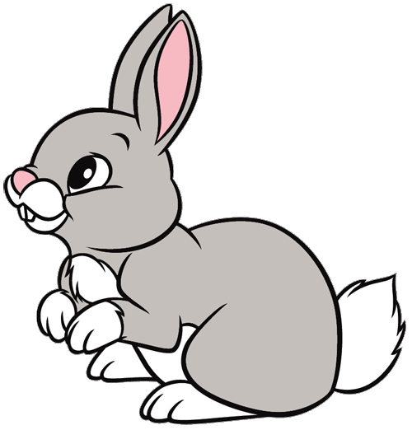
Thursday 25th February

Find out about sharks!
https://www.youtube.com/watch?v=tfWMwG6aYzQ
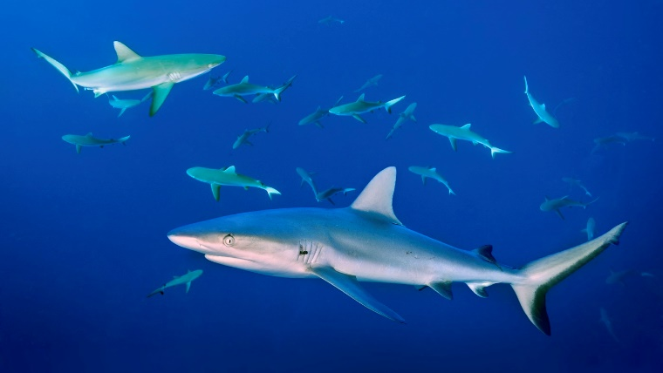
Watch this video about sharks.
Now draw your own picture of a shark. Write the word ‘shark’ using your sounds and fred talking.
You could also make a shark!
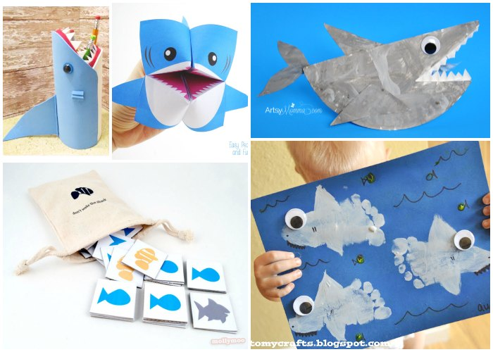
Watch the Octonauts episode about cookie cutter sharks!
https://www.bbc.co.uk/iplayer/episode/b00wwf9y/octonauts-series-1-31-the-cookiecutter-shark
RWI
Can you use your letters to make up some of your own alien words?
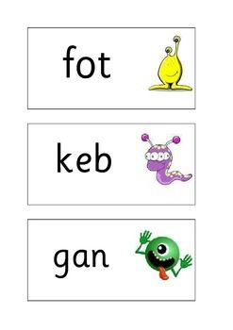
This week I wrote some really silly sentences for you! Do you remember?
I am a bin.
Now try writing a silly sentence just like I did!
You can even add a funny picture to with your sentence, but don’t forget your full stop!

Maths
Please use the number activity attached based on today’s lesson about combining two groups and try some under the sea counting too using the ‘I spy’ sheets.

There are also some colouring sheets today too if you would like to use them.

