Rabbits Home Learning
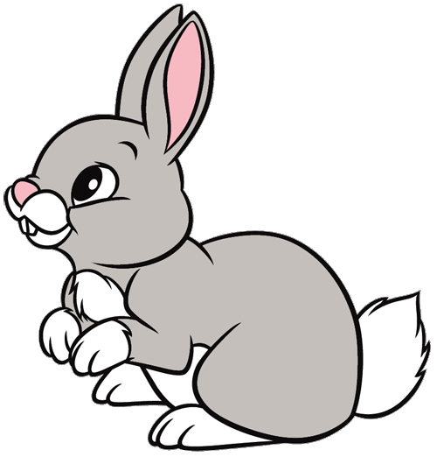
Friday 26th February
Get creative!
Can you make an underwater scene in a box?
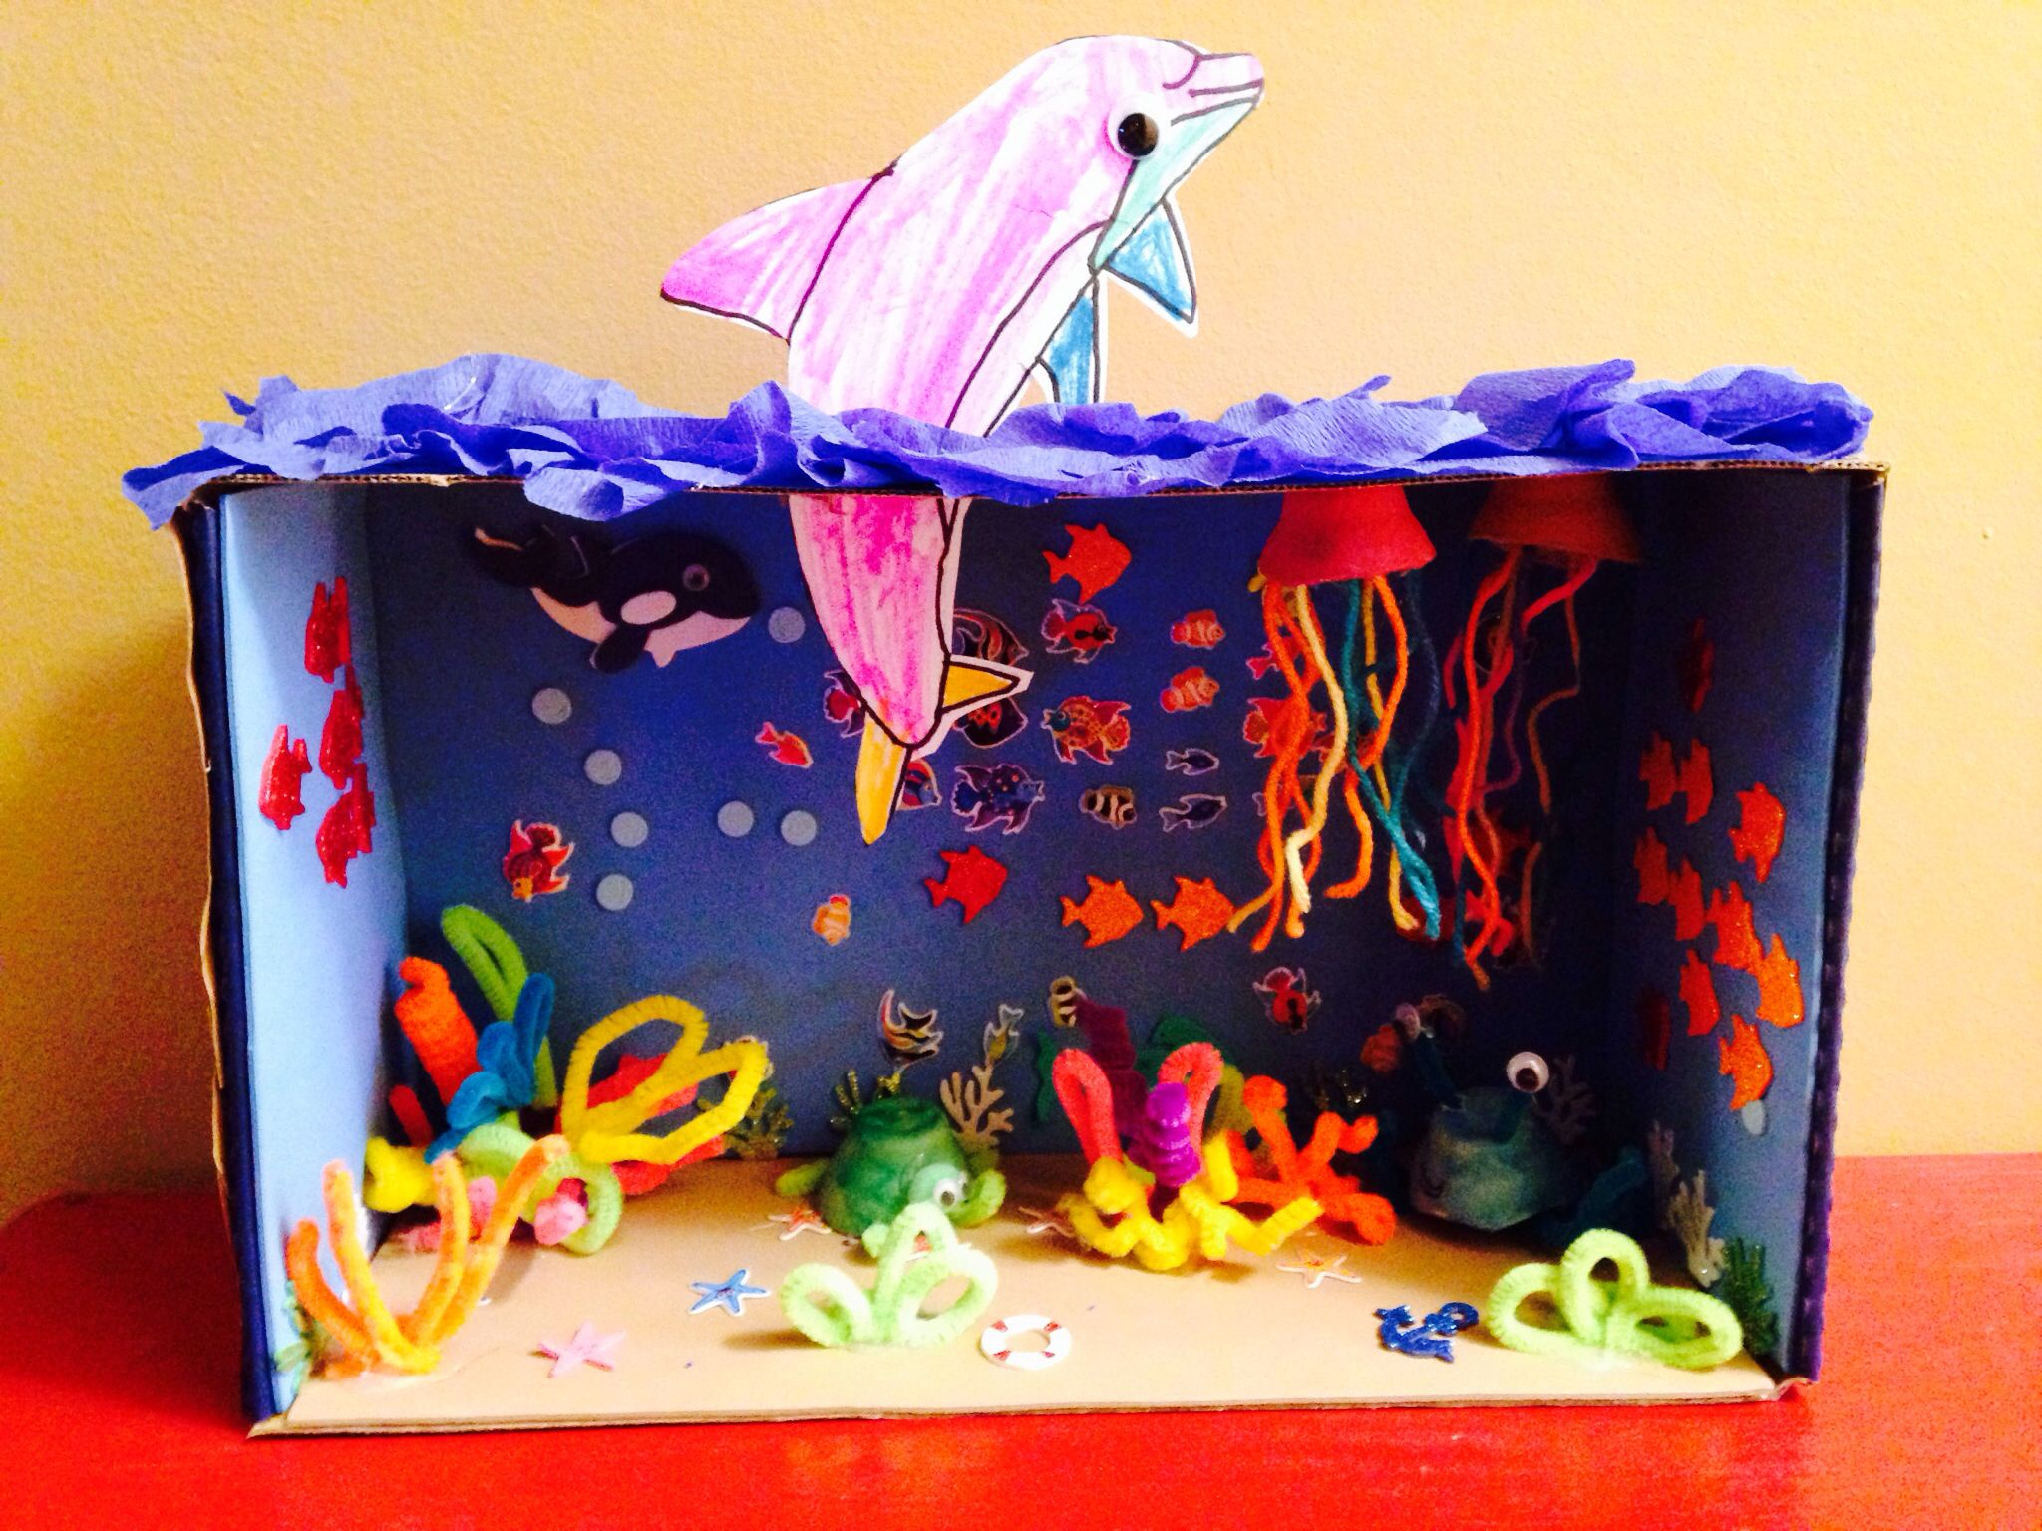
You don’t have to make it all now. This a project for this term…. Part of your home learning for the rest of this term.
So today start collecting some sand, or pebbles or even collect shells from the beach! Which sea creatures do you want to have in the sea?

Here are some other pictures to get you thinking of ideas….
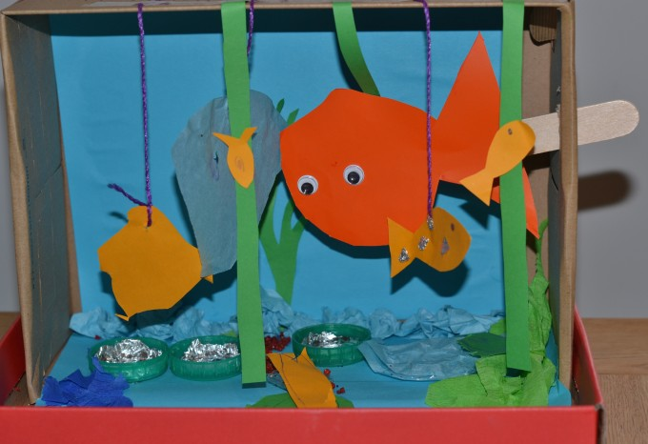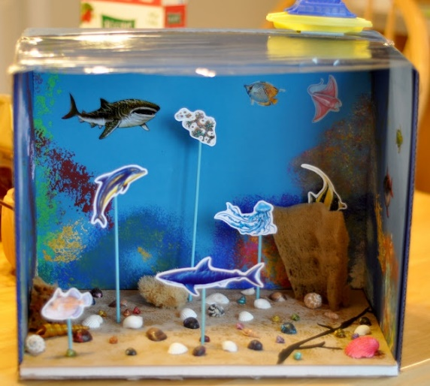

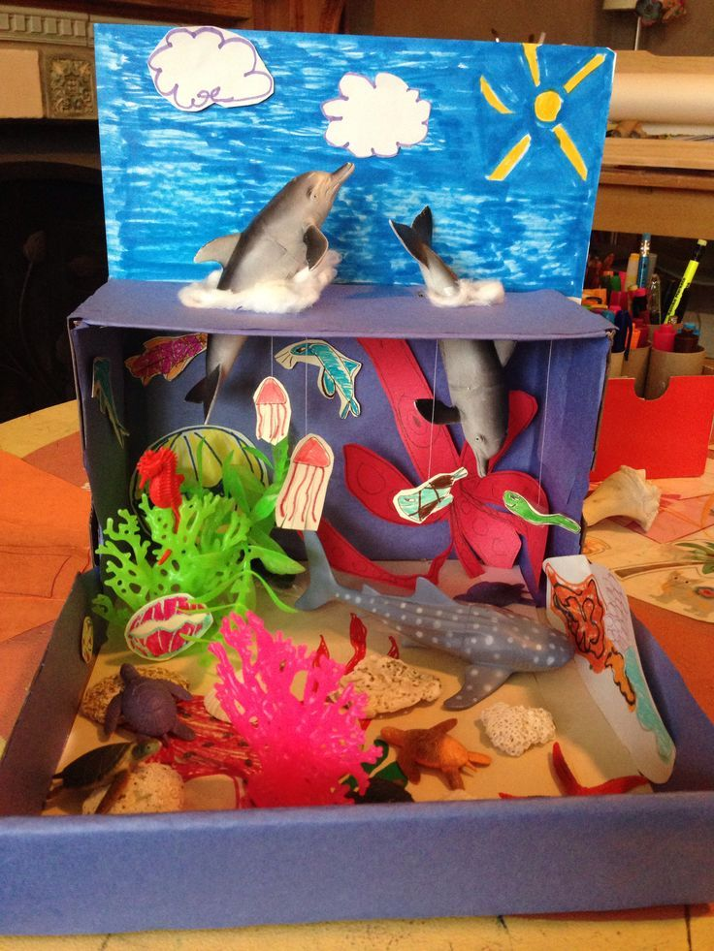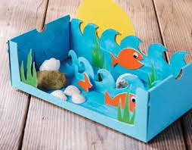

It doesn’t have to be perfect! You might even find some pictures in magazines with sea creatures or cut up some old socks and make them into coral or sea weed.
Please bring them to school to show your friends during the last week of this term.

