Rabbits Home Learning
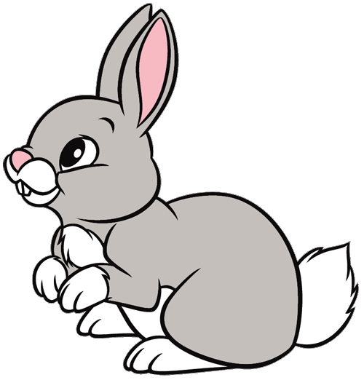
Wednesday 3rd February
English
This week it’s all about dogs!
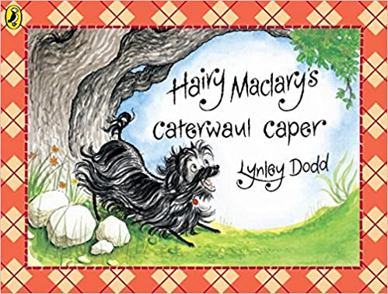
Animated short film of the story.
https://www.youtube.com/watch?v=qF3h8Dg-SXk

Can you practice barking in different ways just like all the different dogs in our story? (sorry parents!)
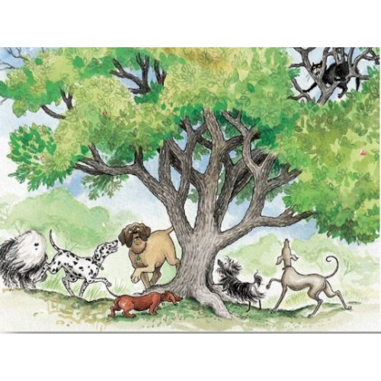
Can you draw or paint your own picture of the dogs watching Scarface Claw up the tree? Now label as many things in the picture using your sounds….. remember no copying an adults writing!
Try words like…. cat, dog, tree, leaf. Even if you just get the first sound that is great. Try some of the dog names too!

RWI
Today’s new special friend is…
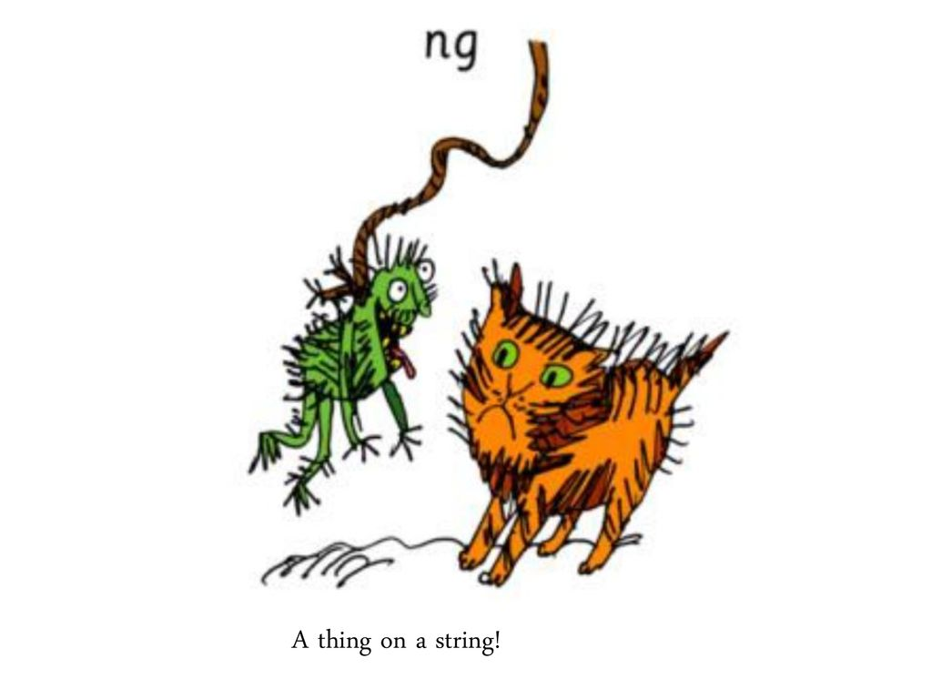
ng
Have a go at matching the words and pictures on the PDF attached.
Don’t forget, the RWI letter formation practice sheets are available to download and print on.
https://home.oxfordowl.co.uk/bookshop/read-write-inc-phonics-reading-at-home/​
They are called 'speed sounds practise sheets' and are at the bottom of this page.

Maths
Please use the attached PDF for today’s Maths challenges relating to measuring capacity.
Please don’t feel you have to use soil and plant pots! Different sized cups and water will work just as well, or fill cups with small pasta shapes, sand or Lego pieces.
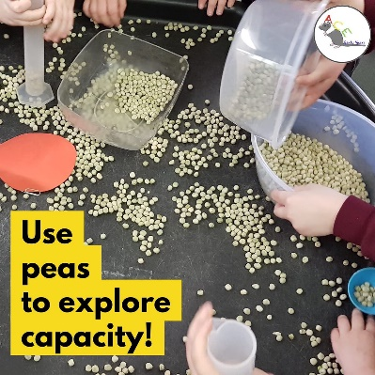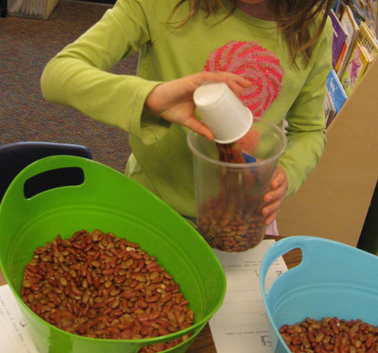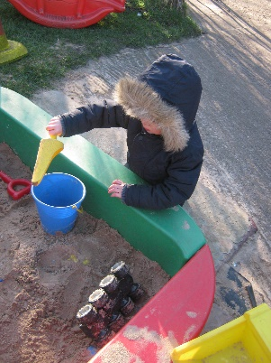

Please can you save a toilet roll tube for later in the week. We are going to use these to make dogs so if you want to make more than one dog, save a few!
