Rabbits Home Learning
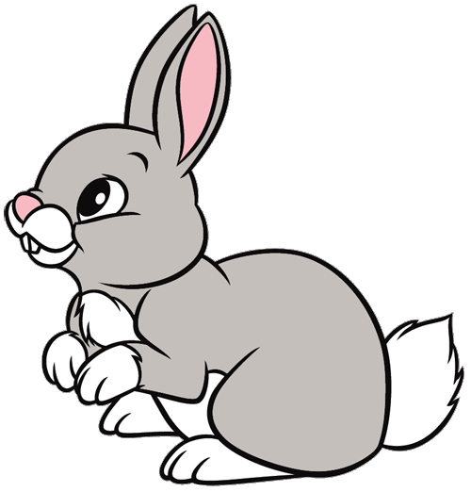
Thursday 4th February
English
This week it’s all about dogs!
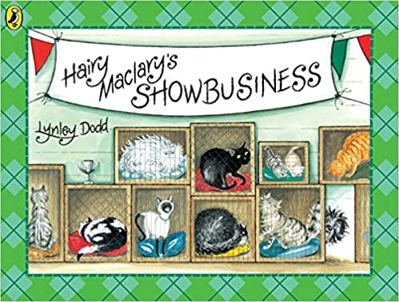
Animated short film of the story.
https://www.youtube.com/watch?v=nQ3N6Zc0S4I

Can you use the sheet to write some words about Hairy Maclary.
“Hairy Maclary is…. (try the word ‘scruffy’, ‘naughty’, ‘funny’ or something else.)”

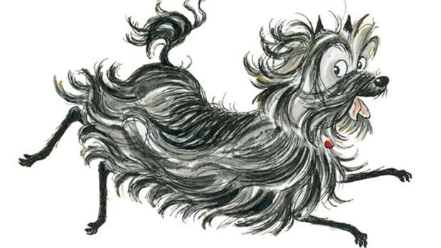
Hairy Maclary gets chased around table, chairs, legs and stairs. Can you make an obstacle course around the house or outside and pretend to be Hairy Maclary escaping?

RWI
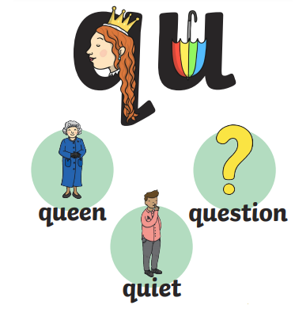
This week we learned ‘qu’.
Can you use the practice booklet to practice the sound and letters?
Maths
Please use the attached PDF for today’s Maths challenge.
If you haven’t got a matchbox just use the smallest container you can find.
There is also some dog counting and colouring if you want to use it.
Please don’t feel you have to do all the attachments but they are there if you want to use them.

