Rabbits Home Learning
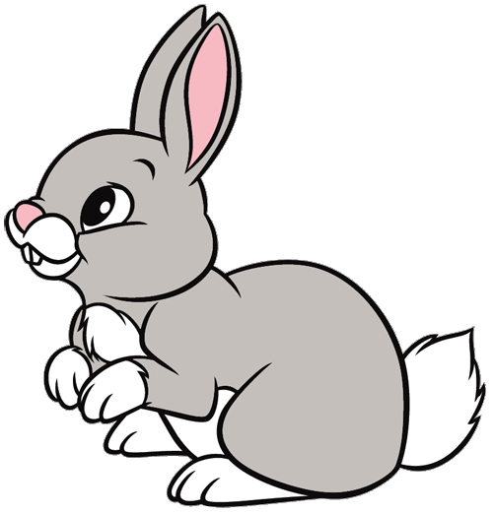
Friday 5th February

I hope you’ve managed to save a toilet roll tube or two!
Have a go at making one of the dogs from our stories this week.
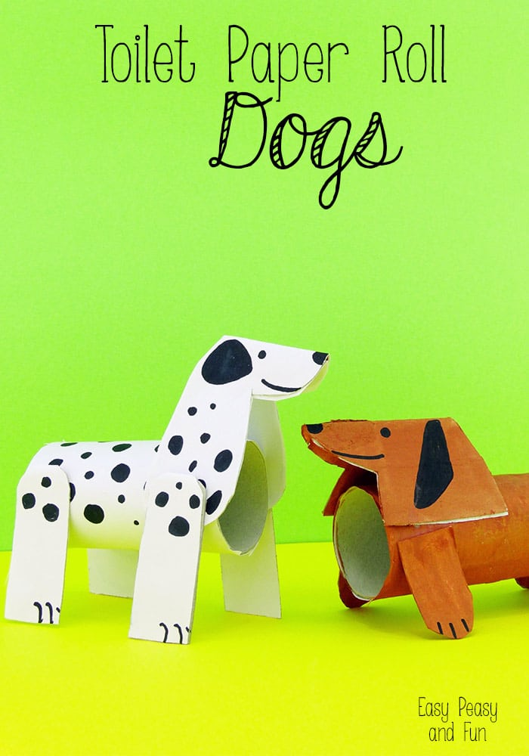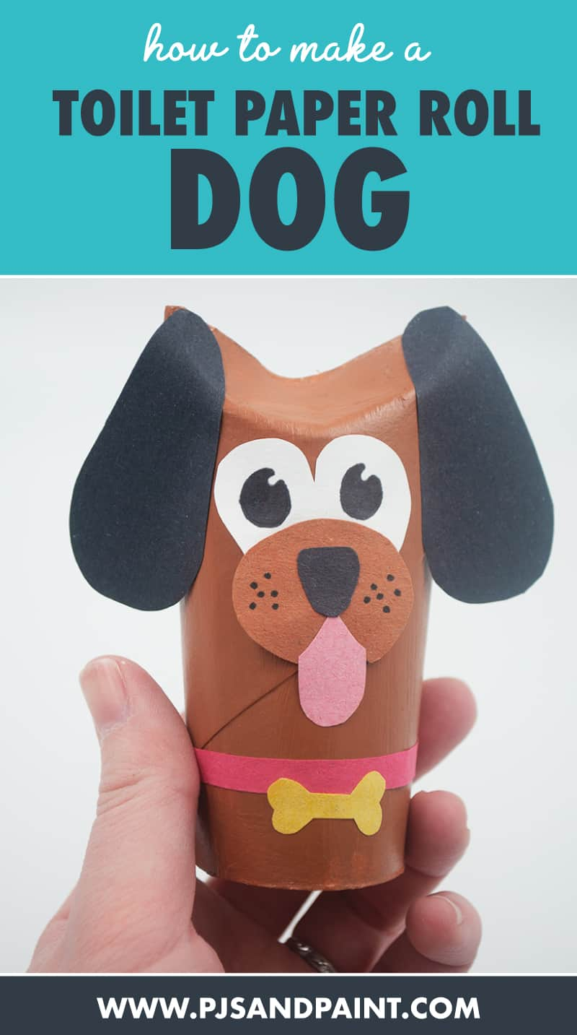
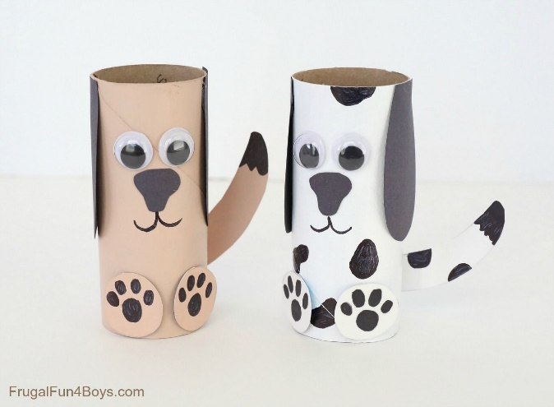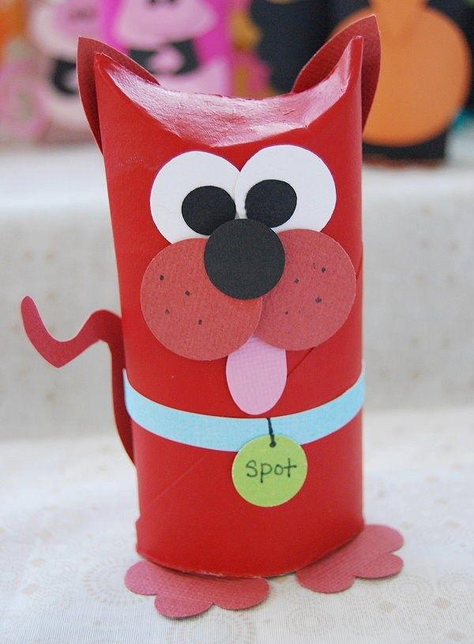

Maths
Today we saw how to make playdough. Try making some yourself or make something else instead. Be careful when you are measuring out your ingredients!
The recipe for playdough is attached to today’s home learning.
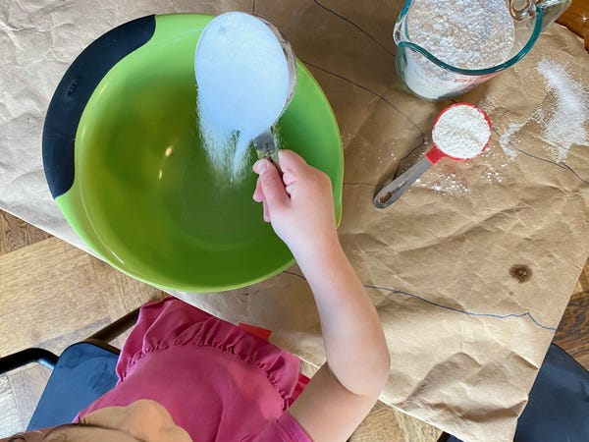

There are also some weighing home learning challenges to try! Have fun!

