Rabbits Home Learning
Monday 8th February
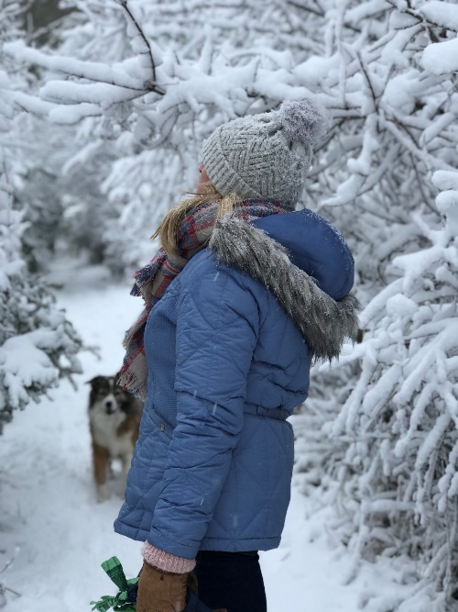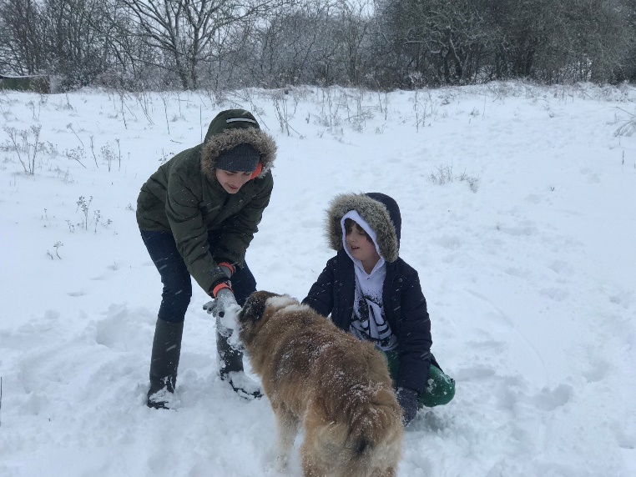
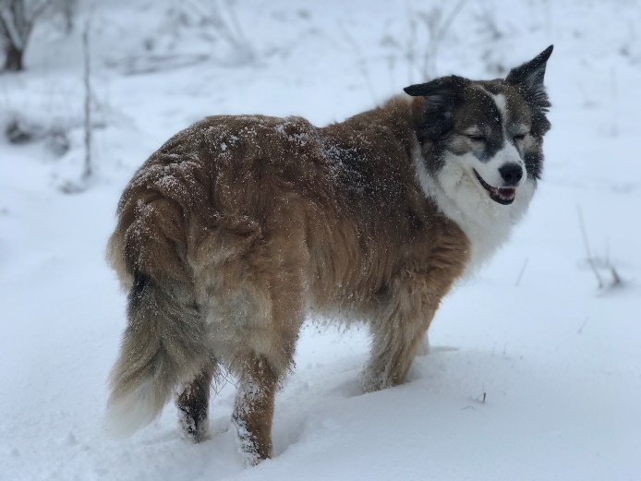
Have a great day enjoying what is left of the snow.
Take lots of photos and you can tell your friends tomorrow all about what you did in the snow.

Today’s live Teams session is cancelled but I’ll see you all on Tuesday.
If you want to you can draw a snowy picture with snowmen, sledges and snowballs or make some snowflakes out of paper.
Missing you already!

