Rabbits Home Learning
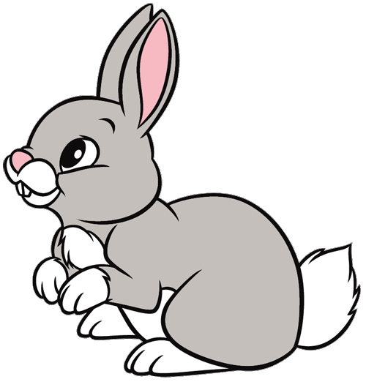
Tuesday 9th February

This week it’s all about cats!
They’re not so easy to show on teams but we’ll give it a go this week. Let me know if you have a cat and you’d like to share!
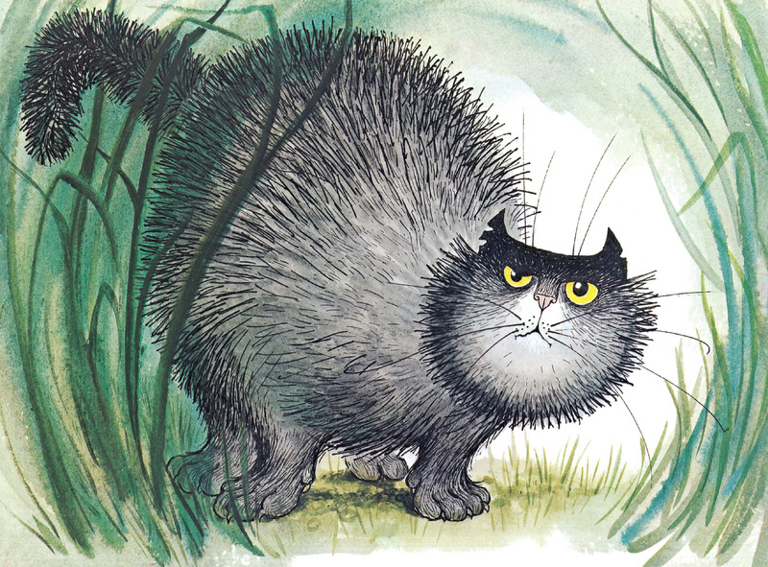
Can you remember who this is?
What is his name?
What noise does he make when he sees dogs?
In the story I read today, what is he not frightened of?

Can you draw your own picture of Scarface Claw today? Make sure he has lots of black fur and those big yellow eyes. What else has he got that makes him look at bit fierce, rough and tough?

If you can, write a simple sentence about Scarface Claw.
(He is big.) (He is black.)
You might need to ask a grown up to help you with the word ‘He’.

https://www.youtube.com/watch?v=edNkYFjO7vo
Read aloud version.
RWI
Practise your speedy sounds.
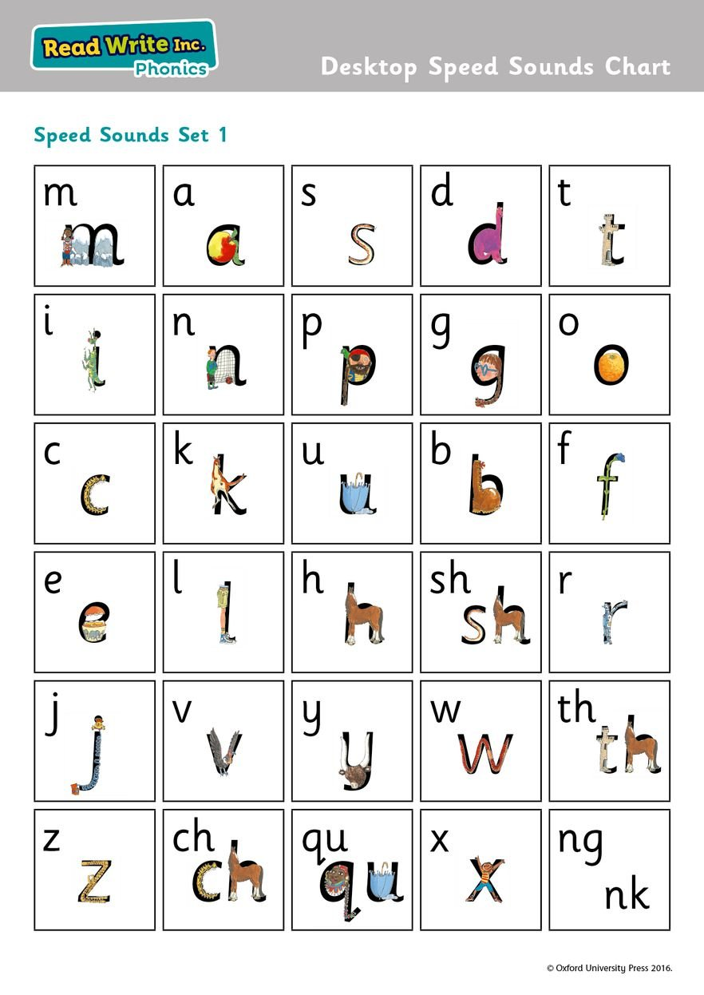
How many can you spot?
Practise speedy writing too.
Today we learned.
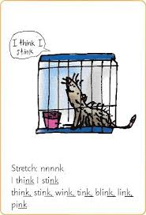
nk
Practise Fred talking the words with an adult.
Remember it’s a ‘special friend’, 2 letters which make one sound!
w……..i……..nk “wink”
Maths
Today we used my number line counting stick.
Can you make your own number line today?
Use paper, sticky notes, chalk, number bricks, whatever you can find.
Start with 1-5 or 1-10 and then try bigger numbers if you can.
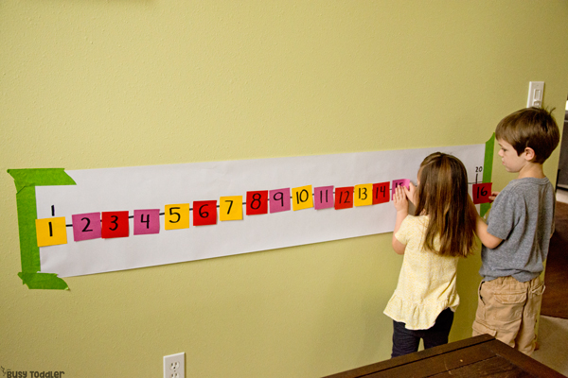
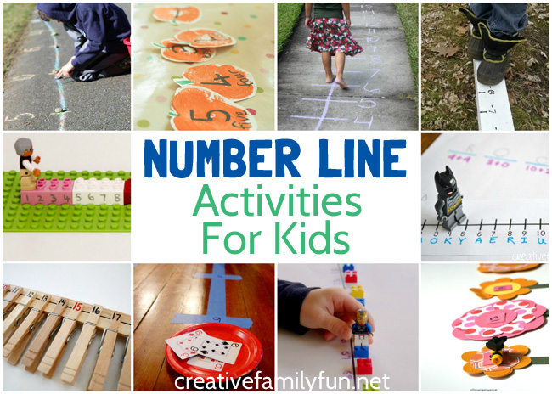
Get an adult to take away one of the numbers… how quickly can you spot which one is missing?

Watch the number blocks episode… number block 11!
https://www.bbc.co.uk/iplayer/episode/m000266y/numberblocks-series-3-eleven
If you’re not sure of your numbers to 10 try another episode on Cbeebies.
https://www.bbc.co.uk/iplayer/episodes/b08bzfnh/numberblocks?seriesId=b08bzg8q

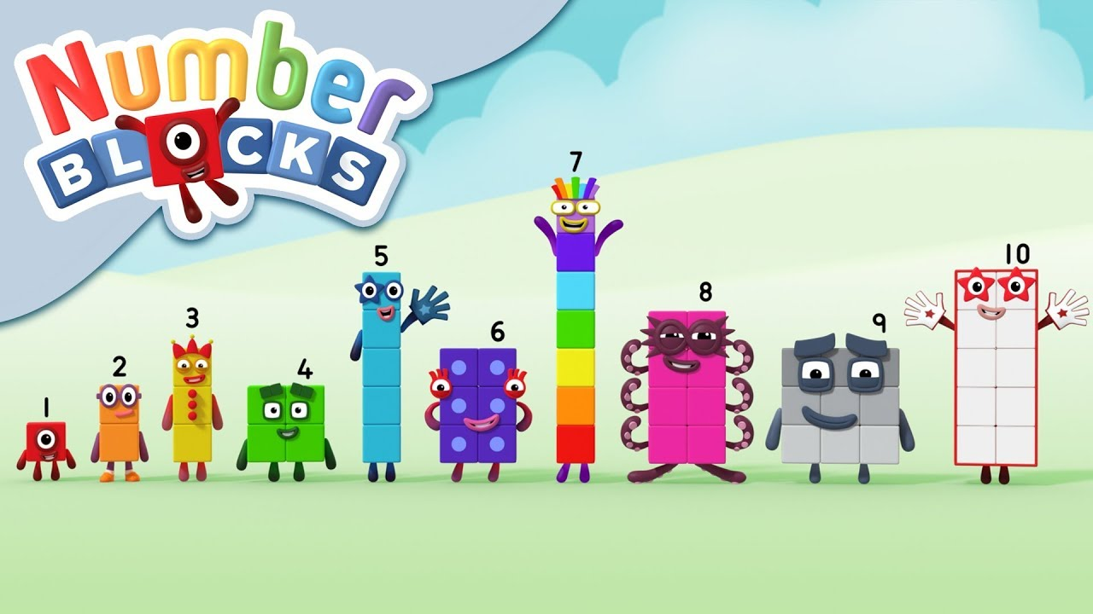
Episodes are on youtube too.

