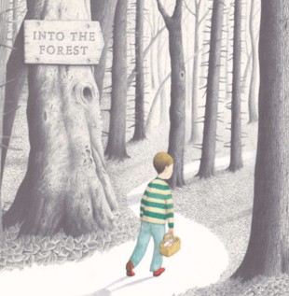
Please send your completed work to lhumphries@charing.kent.sch.uk or upload it onto Teams.
Reading
This term, we will be reading the story Into the Forest by Anthony Browne.
You can listen to this story being read on the following link:
https://www.youtube.com/watch?v=qjgugbdwvMY

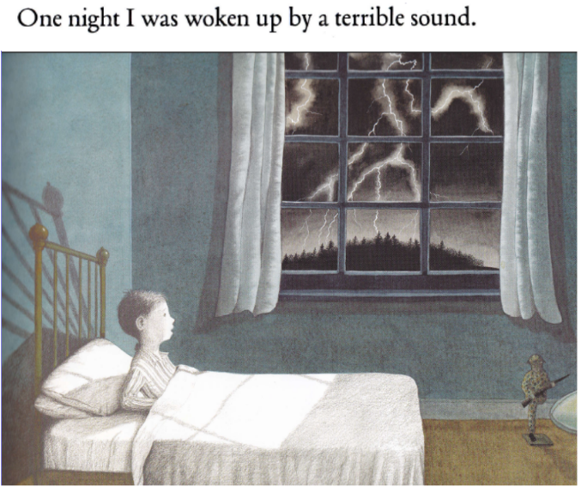

- Why did the boy wake up?
- Can you describe the sound that the boy may have heard?
- How do you think the boy is feeling and how do you know this?
- How would you feel if you were the boy?
- Do you think the first line in the story is good? Why/ why not?
Challenge
Can you up-level the first line in the story to make it better?

