Reading Comprehension

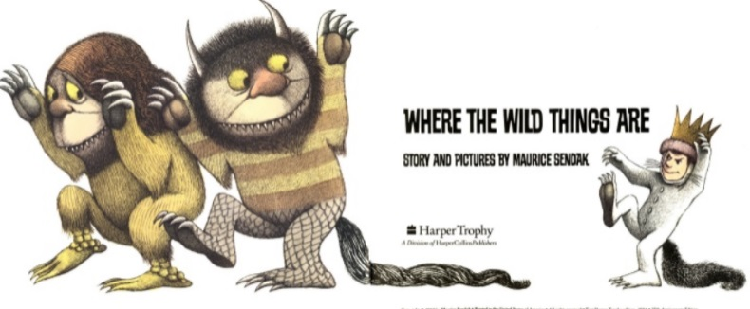
If you need to send your completed work via email, please send to lhumphries@charing.kent.sch.uk

Read the story Where the Wild Things Are- https://www.slideshare.net/samsmith_12345/maurice-sendakwherethewildthingsare
https://www.youtube.com/watch?v=ALmNPxNehYE
Once you have the read the story, I would like you to answer the following questions.

- Why did the wild things give him a crown?

- Write down 2 things they did in the ‘wild rumpus’?

- Why did Max go home?

- What did he see in his bedroom when he got home?

- Have you ever been sent to bed?
What did you do?

Challenge
From the point of view of one of the Wild Things, describe Max and what he did.

