Reading Comprehension

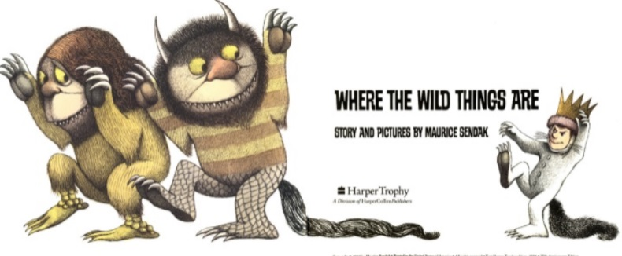
If you need to send your completed work via email, please send to lhumphries@charing.kent.sch.uk

Read the story Where the Wild Things Are- https://www.slideshare.net/samsmith_12345/maurice-sendakwherethewildthingsare
https://www.youtube.com/watch?v=ALmNPxNehYE
Once you have the read the story, I would like you to answer the following questions.

- Why did Max’s mum send him to his room?

- What did his bedroom look like?

- How did Max get to the place where the wild things lived?

- What did he do to scare them?

- How would you react to the wild things and why?

Challenge
What would your own version of a Wild Thing look like? You can draw or write your description.

