Science 1.3.21
Read the following information and remind yourself about the main food groups.
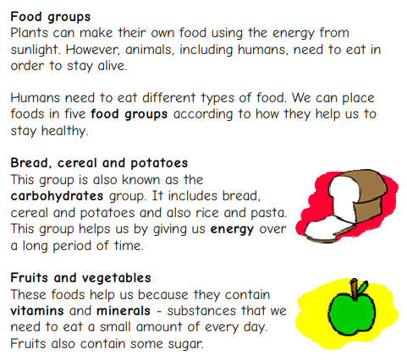

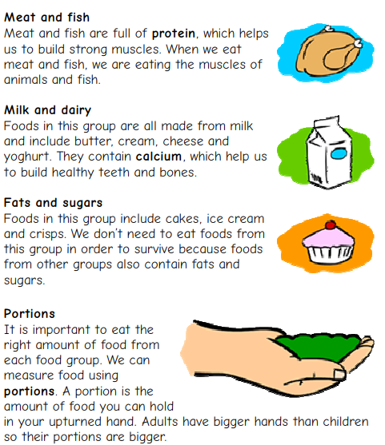

Activity 1
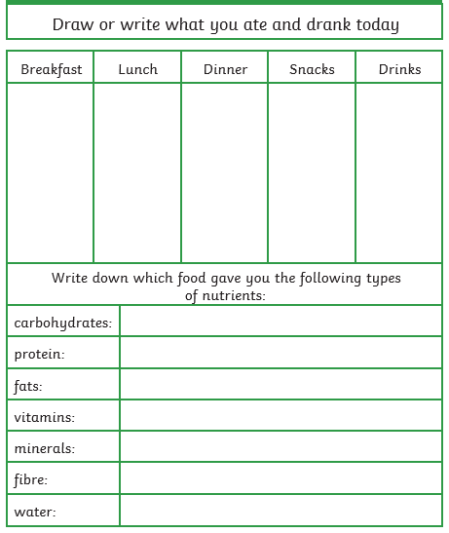

Activity 2
Go to the following website: What types of food do animals eat? - KS2 Science - BBC Bitesize
Watch the video called what types of food do animals eat?

Use the sheet below to fill in the Venn diagram.
