Science 22.2.21
Go to the following web page: The food groups - BBC Bitesize

Activity 1
Match the correct label to the correct food group.
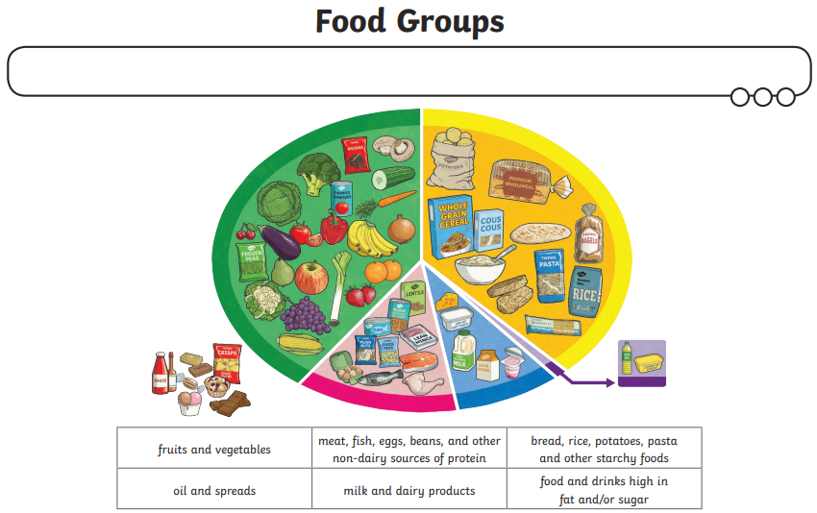

Activity 2
If you are unable to print this out, draw the food and write down the nutrient type and why we need it.
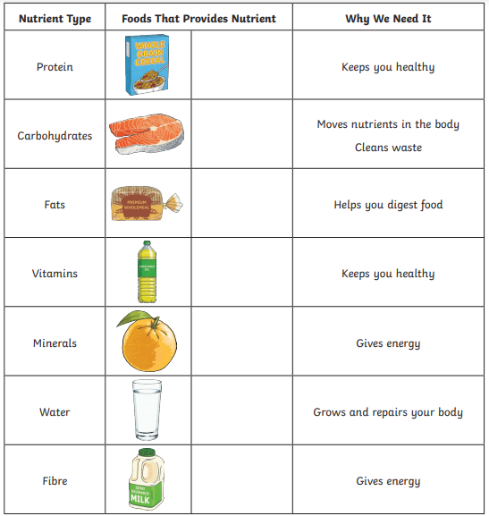

Activity 3
