- Complete the activity below.
- Practise these spellings at home and ask your adult at home to test you.
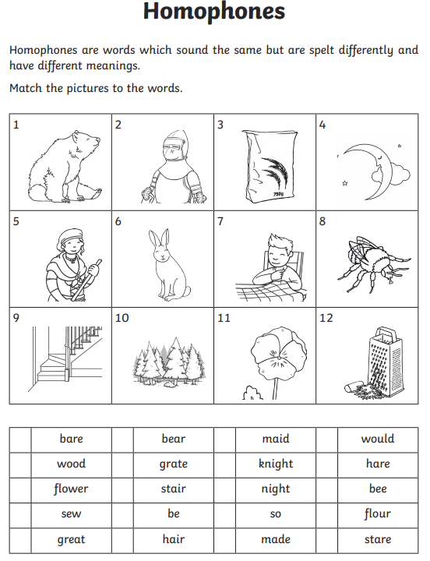

1 =
2 =
3 =
4 =
5 =
6 =
7 =
8 =
9 =
10 =
11 =
12 =

