Spellings 22.2.21
Learn as many of these science words you can.

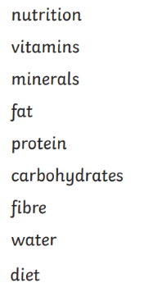

Challenge
Write your own dictionary definition. Then use each of these words in sentences of your own.

